Trip Plan
Trip Name (location & type of trip): |  |  | Destination:
Departure Date & Time: |  |  | Estimated Return Date & Time:
 | Leader 1 |  |  | Leader 2 | Leader 3
Name:
Email:
Cell # :
Cell Carrier:
Medical Certification type
Van Driver Trained? WVDT?
Food Handlers Permit?
Vehicle Information | Driver Name: |  |  | Driver Name: | Driver Name:
UPS, Enterprise, ASUPS, Budget or Owners name
Make and Model
Color
License Plate #
Trail and Destination Information* (May be filled out after coordinator meeting if location may change)
Trail Head Name – Entrance / Exit
County & State of destination:
(specify if part of the trip is in a different county)
County Sheriff’s Office telephone number
Nearest Medical Center
Nearest Hospital
Land Owner
(forest Service, National Park, State Park, BLM…)
Permits/Reservations Need?
Confirmed
Campsite or Campground for each night

What is this trip about?
Activity Level:
- 0-3m w/ 0-1K gain |  | - 3-5m w/ 2-3K gain |  |  | - 6+m w/ 3-5K gain
Skill Level:
No Exp. | Previous Exp. |  | Intermediate |  |  |  | Advanced
Who is this trip aimed for?
Participant Cost Estimate (Coordinators will fill this out):
Email Blurb ( Be Creative):
Are you advertising through any other source? If yes describe
Approved By (all three coordinators): |  |  |  | X | Date
Olivia Drukker
Hadley Reine
Justin Canny

WORK, CLASS, & COMMITMENTS SCHEDULE
Please Mark Any Time that as a pair you are not available (as Leader A,B, or C)
A: |  |  |  |  | B: |  |  |  |  |  |  |  | C:
TIME |  | MONDAY |  |  |  | TUESDAY |  |  |  | WEDNESDAY |  |  |  | THURSDAY
 |  | A | B | C |  | A | B | C |  | A | B | C |  | A | B | C
2:00 – 3:00 pm
3:00 – 4:00 pm
4:00 - 5:00 pm
5:00 - 6:00 pm
6:00 - 7:00 pm
7:00 - 8:00 pm
For Coordinators use
 |  |  |  |  |  | Date |  |  |  | Time |  |  |  | Location
Trip Pre-Brief
Trip Meeting
Tabling
Final Check in
De-Brief

Risk Assessment and Analysis Form

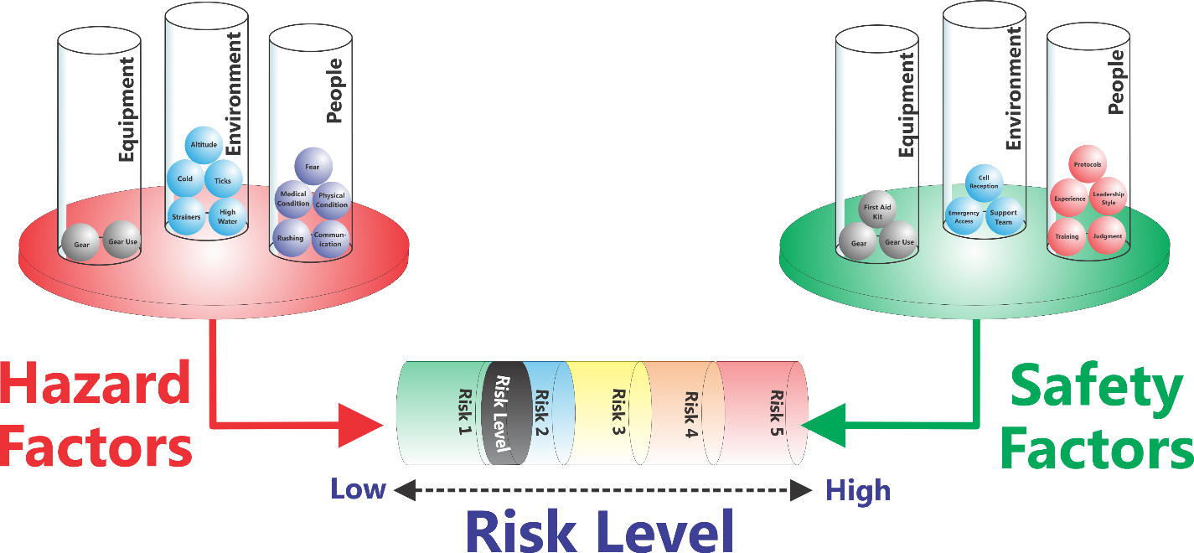
Hazard Factors |  |  | Risk Level | Safety Factors
Equipment | Environment | People |  | Equipment | Environment | People

Application:

For your PSO Trip brainstorm a list of Hazard Factors in each of the three major categories (Environment, Equipment, People)

For each program activity brainstorm a list of Safety Factors in each of the three major categories (Environment, Equipment, People) designed to mitigate against Hazard Factors

Balance the Hazard Factors against the Safety Factors and determine the range of Risk Levels you will be operating in. Based on your program, decide whether the Risk Level is acceptable or not.

If not, determine where to make changes (reducing hazard factors, increasing safety factors, or both) to reach an acceptable Risk Level.

Included on the trip proposal | Attached Separately
- Driving Directions, Route Map & Area of Activity  - Suggested Itinerary | - Equipment check-out list filled out  - Security Sheets – print out page 1 of this proposal  - Participant list – receive from Expy Staff or in your trip box on Friday afternoon 2 copies, 1 for Security and 1 for trip leaders

Driving Directions, Route Map & Area of Activity
Please attach or specify where you will find the following.
- Driving directions – use google maps as a basic reference for time and directions THEN make sure to check the Gazetteer on the wall at the Expy. You and your co-leader need to know how to get there via the Gazetteer. Google maps does not go to all trailheads. Remember to account for in driving times the slower speeds that 15 passenger vans operate at.
- Name of topographic map(s) or Attach a PDF from Cal Topo – you can find this on the Washington Trails trip descriptions and via the TOPO mapping program at the Expy. If included in this section the PSO coordinator will be able to pull or print the requisite maps before the meeting.

Plan B: Same activity within close driving distance to your original trip.

Suggested Itinerary:
It is important to figure out this information so that you have a basis for knowing if the route needs to be changed based on the movement of the group. Hiking time can be estimated by taking travel taking:
- Hiking Distance / Hiking speed at 1-2m.p.h
- Add 1 hour for every hour of significant elevation gain over 1,000 ft. of vertical
- Add in your break time and lunch time

 | Day 1 | Day 2
Driving time:
Start/Trailhead Name:
Mileage:
Hiking time:
Elevation gain:
Break and Lunch time:
Total Hiking time:
End/Campsite:
Lodging Needed:
Total Travel Time:

Use the following table to plan out your activities, please feel free to add more rows if necessary

Day | Time | Location | Activity/Event | Notes

