Part 1) How to edit your timeline entries with HTML commands:
Some of you have asked me how to modify the look and feel of your timeline entries. Here are a few basics--
You can use HTML commands to change the appearance and format of the content in any of the text fields (headline, text, caption, and credit) in your TimelineJS3 spreadsheet. Most HTML commands have two parts, which are placed at either end of the material you want to modify, i.e.,
<command start> [the material you want to change goes here] </command end>
Some HTML commands you may find handy*:
If you want to… | …use this command:
create a line break | <br> your text <\br>
create a paragraph break (to display each of your sources on separate lines, for example) | <p> your text </p>
align a paragraph to the left (default), right, or center | <p align="left"> your text
change the font size | <font size="3"> your text </font>  (use any number from 1 to 7, 1 being the smallest)
indent text from both sides | <blockquote> your text </blockquote>
change the font color | <font color="green"> your text </font>  or  <font color="#[six-character hex code for the color you want]"> your text </font>
change the font style to bold | <b> your text </b>
change the font style to italics | <i> your text </i>
create a numbered list | <ol> your text </ol>
create a bulleted list | <ul> your text </ul>
*(Adapted from http://www.simplehtmlguide.com/text.php)

So, if I wanted to change the look of my Works Cited page from this—
…to this—
--I would edit my spreadsheet entries for the Works Cited page as follows:
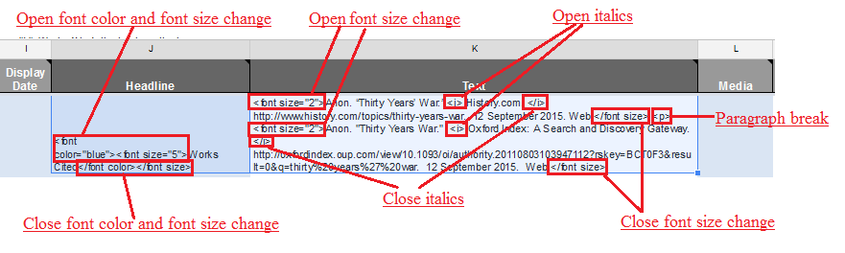
Then I would republish the timeline and re-preview it on the Timeline JS3 site.
Part 2: How to Share Your Timeline with me (so I can give you a grade)--Once your timeline is displaying information the way you want it to, you’ll need to send me a link to it and give me permission to view it. Here’s how to do that:
- Be sure you’ve published the timeline.
- With your timeline open in Google Drive, click Share:
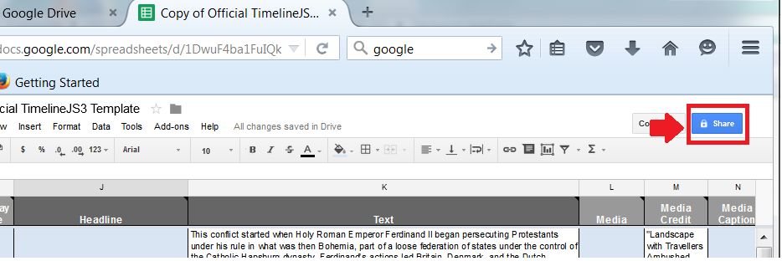
- Type my email address in the box as shown:

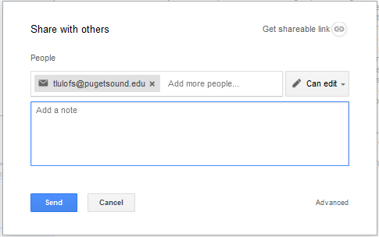

- In the text box, list all the event annotations your wrote (so I’ll know definitively which work is yours), and click the link icon next to Get shareable link:
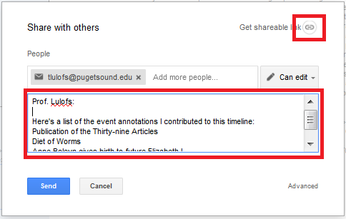
- Click Send:
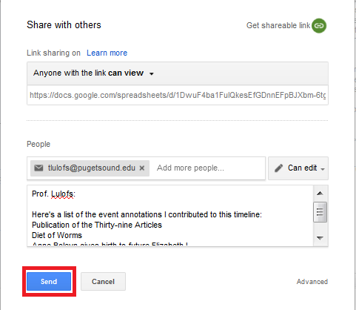

That should take care of it.

