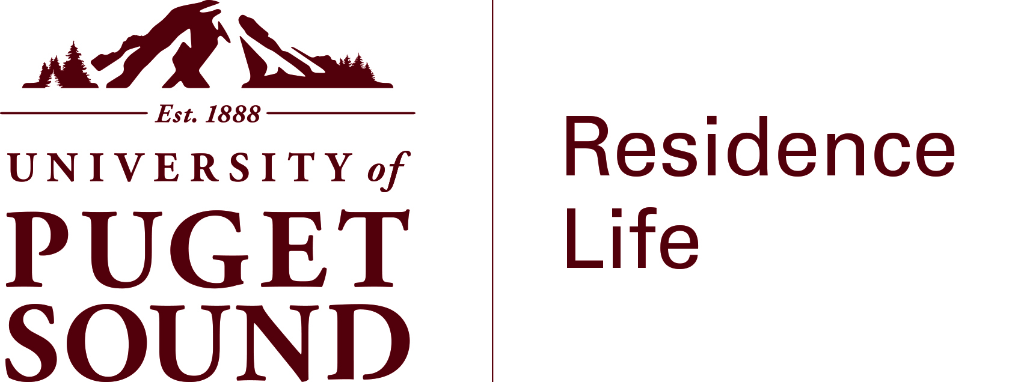

Residence Life Staff
Resume and Cover Letter Guide

What do you need to know?
A cover letter and resume tell a story of your experiences, highlight relevant skills and abilities, and demonstrate your ability to write in a professional manner. While your resume is a good summary of your past work and or volunteer experience, your cover letter is your way to set yourself a part. For many applicants for Residence Life, resume experiences are similar. The cover letter allows you to delve more in depth to a particular experience that highlights what you bring to the team. It is also a great way to show your understanding of the needs and challenges of the position, and how you would best meet these expectations. For both your resume and cover letter, pay particular attention to the format and content for spelling and grammar errors. These documents are one way to show how effectively you can communicate in writing.

Career and Employment Services (CES) is a great resource to support and assist students in the process of developing a resume or cover letter. Here is the link to the comprehensive guide to make a resume and/or cover letter.

For Residence Life, we are most interested in hearing from you in your own words why you want to be a part of our department, and what you would bring to the team. Some examples of experiences that one may want to consider are listed below. What you can include is not limited to the suggestions provided below—they are simply examples:

Interpersonal skills: from clubs, organizations, or other leadership opportunities in which you participated in such as attending conferences, or facilitated meetings; part-time jobs such as customer service, and volunteer work
Campus Involvement: from an on-campus job or extra-curricular activity that interacts with different offices on campus, club participation or leadership
Policy enforcement skills: from involvement with Peer Boards or Honor Court, camp counselor experience or from other leadership experiences.
Academic commitment: current or previous honor society membership, fellowships, scholarships, honor roll, dean’s list
Health and safety experience: Eagle Scout, first aid certification, lifeguard experience, safety training, food service handler’s permit and/or experience.
Organizational skills and energy: Demonstrated ability to manage class load and extra-curricular activities, work/life balance
Residence Life experience: RHA involvement, NRHH involvement, RSA involvement, participating in community activities and programs, etc.

Do you have more questions or concerns?
Regarding Residence Life Student Staff selection process:
Residence Life is located in the Student Development House at 3209 N. 15
E-mail reslife@pugetsound.edu and/or call (253) 879-3317

Regarding how to create a resume and cover letter or preparing for interviews, please contact CES.
CES is located in Howarth Hall Room 101. Their e-mail is ces@pugetsound.edu, phone: (253) 879-3161

