Emma Harrington PG 410
December 17, 2019 Professor Sousa
Do the Affordances of Social Media Platforms Make Them a Tool to Increase the Representation for Female Politicians in Congress?

Introduction

Although the U.S. is currently being governed by more women than at any other point in the nation’s history, the female population and the ensuing needs of women are grossly underrepresented in both American and global politics. This gender gap is academically explained through evidence that women lack the same “ambition” and desire men have to run for public office for several reasons. One such reason that women are less likely to hold political aspirations is the historically gendered and unequal coverage of female candidates by traditional media outlets. The emergence of social media platforms has not only changed everyday life in the 21st century but has also greatly altered the realms of politics and news which may provide an opening for would-be female candidates to overcome the barrier that traditional media presents. A survey of global research on social media affirms that such platforms can be a tool used by female candidates in campaigning, under the right set of circumstances, to contend with traditional narratives, lessen the ambition gap, and ultimately increase female representation.
One of the major identified drawbacks to digital campaigning is a lack of how-to knowledge and

understanding of best practices on social media sites. An iterative analysis of three case studies

on hotly contested congressional races from the 2018 midterm elections helps to broaden the understanding of how candidates are currently utilizing the increasingly popular photo-sharing platform, Instagram. Such an understanding of current practices is the foundation on which to develop ways to increase how-to wisdom and knowledge on effective use. The widespread sharing of such knowledge may ultimately aid in increasing overall female representation in American politics.

- Where are the Women in Politics?: Female Underrepresentation in U.S. Politics

Women may make up fifty-one percent of the total U.S. population;1 however, the

number of women in our political system is nowhere near representative of this near-even split.2

Female U.S. citizens have barely had the legal right to cast a ballot for 100 years (even less when one looks at women identifying as members of ethnic minorities)3 and the progress for women

1 “U.S. Census Bureau QuickFacts: United States,” Census Bureau QuickFacts, U.S. Census Bureau, December 15, 2019, https://www.census.gov/quickfacts/fact/table/US/LFE046217.
2 The author behind this work would like to acknowledge that the understanding of gender as a binary between male and female has been shifting in recent years. In many circles, including parts of academia, gender is understood to be both a social construct and to exist on a spectrum to include those who identify with no gender, more than one gender, or a gender outside the traditional binary. While the prominence of non-binary and transgender individuals in politics is slowly increasing in the United States (Beachum; Lyons), traditional political science literature relies on a binary understanding and gender-exclusive terminology. Additionally, the barriers to entry in the political arena look different for those who identify as female, present as female and are biologically female, than those who identify outside of the gender binary. These specific barriers warrant additional research but are outside of the purview of the current work. Also with this acknowledgment, moving forward, the terms ‘woman’ and ‘female’ will be used interchangeably to refer to female-identifying and female-presenting individuals.
3 Race is currently a hot topic for political science research, particularly in the wake of the first person of color holding the office of President, and as the United States continues to polarize around issues such as immigration, voter ID laws and redistricting. In reference to the topic at hand, people of color are also visibly underrepresented in politics, especially in relation to the American electorate. There are only 47 women of color currently serving in the 116th Congress and only 17 in statewide elective executive offices (“Facts on Women of Color in Office”,

holding political office has been just an incremental. The election of 1978 was the first year a woman was elected to the U.S. Senate who was not replacing a deceased male spouse, and it was not until 15 years later in 1993 that, “more than two women serve[d] in the chamber simultaneously.”4 2018 has replaced 1992 (in which a record breaking number of female U.S.
Senators were elected) as the ‘Year of the Woman,’ given that a number of records for female political representation were broken after the November midterm elections. The 116th Congress, currently in session at the time of writing, has a record-breaking 102 female elected representatives.5 Additionally, there are not only a record number of female state legislators across the nation, but Nevada became the first state in the history of the United States to have a legislature composed of 50% women.6
However even after a record-breaking election, “women continue to make up less than one-quarter of the elected officials in … state capitals and city halls.”7 In total, only 44 women have served in the position of state governor and only 56 have served as senators.8 Even the record-breaking number of female members of Congress is misleading progress as it brings the

CAWP). Similar to the caveat regarding the gender binary, the barriers to entry in the political arena look different for women of color and these specific barriers warrant additional research but are outside of the purview of the current work. In acknowledging this, the majority of statistics included here refer predominantly to white women. This is also reflected in the choice of cases to be studied.
4 Danny Hayes and Jennifer L. Lawless. Women on the Run (New York: Cambridge University Press, 2016), 111.
5 Danielle Kurtzleben et al. “What It Looks Like To Have A Record Number Of Women In The House of Representatives,” NPR, January 4, 2019, https://www.npr.org/2019/01/04/678227272/ what-it-looks-like-to-have-a-record-number-of-women-in-the-house-of-representati
6 “Women In State Legislatures for 2019,” National Conference of State Legislatures, 14 Feb. 2019, http://www.ncsl.org/legislators-staff/legislators/womens-legislative-network/women- In-state-legislatures-for-2019.aspx.
7 Hayes and Lawless, Women on the Run, 111.
8 “Women In State Legislatures for 2019,” National Conference of State Legislatures.

share of women in Congress up to just 23.7%.9 These numbers become much less impressive and

less representative of the aforementioned U.S. population when compared to the 333 men serving in the House. It is also important to note the partisan disparities within the gender representation gap as there are only thirteen Republican Congresswomen and that gap appears to be widening because, while the 2018 midterms saw 35 Democratic women become freshmen in the House, “there will be only one on the Republican side: Carol Miller of West Virginia.”1011
While some parity has been made at the state and local level, it is the highest rungs of the political ladder which remain void of equal female representation. Although Hilary Clinton was the first presidential nominee for either of the major political parties during the recent 2016 presidential election, the U.S. has never had a woman sitting behind the desk in the Oval Office even though fifty-nine other nations have had women serve as heads of state.12 As two of the premier researchers on women in U.S. politics, Jennifer Lawless (University of Virginia) and Richard Fox (Loyola Marymount University) put succinctly, “many enclaves of male dominance crumbled across the last half of the twentieth century, but high-level electoral politics was not

9 Danielle Kurtzleben et al. “What It Looks Like To Have A Record Number Of Women In The House of Representatives.”
10 Ibid.
11 Throughout this piece, there will be numerous references to partisan discrepancies in regard to the gender representation gap. There is a growing body of research and evidence illustrating that the gender gap is much wider within the Republican party (Sanbonmatsu; Freeman; and Norrander and Wilcox). Although the affordances and uses of social media promote partisan bubbles, it is also a tool available to anyone with internet access and an email address (which in themselves have inherent privilege) and therefore this work will explore its usage on both sides of the aisle. The structural and cultural barriers specifically placed on women in the GOP deserve and are attracting research in their own right and are not the focus of this piece.
12 Amanda Willis et al. “All the countries that had a woman leader before the U.S.,” CNN Politics, January 28, 2019, https://www.cnn.com/interactive/2016/06/politics/women- world-leaders/.

one of them.”13 In fact, the World Economic Forum estimates that at the current pace, gender

equality will not be reached for over a century.14

This piece begins with statistics illustrating the extreme under-representation of women in a nation based on the ideal of “taxation without representation” and the idea that laws should not bear on those whose voices were not represented in their creation. The study of women in politics is relatively new and scholars involved “have fought to convince the political science community to take the women and politics subfield seriously”15 and therefore “nearly all of the
research that addresses gender and U.S. politics … tends to begin with a justification for studying women and elections.”16 The above justification relies on the same “normative
underpinning” of underrepresentation as previous work; however, “it remains a potent reflection of reality; women’s presence in our political institutions bears directly on issues of substantive and symbolic representation.”17
As cliche as the “underrepresented” argument may be, the literature suggests that “the inclusion of more women in positions of political power would change the nature of political representation in the United States.”18 This change would mean more attention given to
gender-salient issues and give the U.S. government a greater degree of legitimacy, “simply

because it would be more reflective of the gender breakdown of the national population.”19

13 Jennifer. L. Lawless, and Richard L. Fox. It Takes a Candidate: Why Women Don’t Run for Office (New York: Cambridge University Press, 2005), 7.
14 “The Global Gender Gap Report 2018,” World Economic Forum, Accessed December 6, 2019, https://www.weforum.org/reports/the-global-gender-gap-report-2018.
15 Lawless and Fox, It Takes a Candidate, 5.
16 Ibid.
17 Ibid.
18 Lawless and Fox, It Takes a Candidate, 7; Burrell, Barbara, Gender in Campaigns for the U.S. House of Representatives (Ann Arbor: The University of Michigan Press, 2014).
19 Ibid.

Additionally, a correlation has been found between the percentage of females in a state legislature and female citizens’ levels of external efficacy, or belief that the government will respond to their demands and needs.20 A similar positive relationship has been found between the
presence of highly visible female politicians and adolescent girl’s expectations of political engagement.21 Overall, female representatives in state-wide political positions have led to
“higher levels of political knowledge, interest, efficacy and activity” in that state’s population22.

On a global scale, increasing the number of female representatives has shown to not only “bring new perspectives to policy making” but to “make government more responsive -- not only to underserved populations, including the poor and children -- but to all strata of society.”23 Women’s equal representation in government has also been found to increase public trust in political institutions.24 These all seem like they would be positive advancements, which begs the
question, why are women still so underrepresented in politics at all levels?

20 Lonna Rae Atkeson, and Nancy Carrillo, "More is better: The influence of collective female descriptive representation on external efficacy," Politics & Gender 3, no. 1 (2007): 82.
21 Christina Wolbrecht, and David E. Campbell, “Role models revisited: youth, novelty, and the impact of female candidates,” Politics Groups, and Identities 5, no. 3 (2016).
22 Christina Ladam, et al, “Prominent Role Models: High-Profile Female Politicians and the Emergence of Women as Candidates for Public Office.” American Journal of Political Science 62, no. 2 (2018): 373.
23 Thomas E. Patterson, Social Media: Advancing Women in Politics? Brussels: Women in Parliaments Global Forum, 2016: 7.
24 Lucina Di Meco, Women’s Political Networks. Defining Leadership, Breaking Barriers, and Fostering Change, Washington D.C.:The Wilson Center, 2017; Sarah F. Anzia, and Christopher
R. Berry, “The Jackie (and Jill) Robinson Effect: Why Do Congresswomen Outperform Congressmen?” American Journal of Political Science 55, (2011); David Dollar et al, “Are Women Reall the Fairer Sex? Corruption and Women in Government,” Journal of Economic Behavior & Organization 46, no. 4 (2001).

- Traditional Theories on Female Underrepresentation in U.S. Politics

There are a few traditional theoretical strands that have come out of this emerging area of study to explain the discrepancy in female candidates and representatives in comparison to the
U.S. electorate. The earliest conclusion appears to be that “overt discrimination” against women was the primary causal factor.25 However, as more extensive research was conducted, the kind of
overt discrimination, bias, and sexism expected to cause the gap was not substantiated.26 Utilizing a similar line of thinking, another group of scholars bought into the “pipeline” explanation. An analysis of the members of the 109th U.S. Congress found that prior to their roles as representatives, the leading professions that precede a congressional run were in law, business, medicine, and education.27 Similar results were found at the state legislative level.28 These are careers and professional arenas which women have traditionally and historically been excluded from and has thus led to an exclusion from the political career “pipeline” at all levels of governance.29 Through the “pipeline” explanation, many scholars came to the more optimistic
conclusion that because “... women have made significant gains entering the formerly

male-dominated professions of law, business, and medicine”30 similar gains in the political arena

should not be far behind. Many hoped that “as open seats emerge and women continue to move into the professions that precede political candidates, more women will seek and occupy

25 Lawless and Fox, It Takes a Candidate, 21; Marianne Githens, and Jewel L. Prestage, A Portrait of Marginality: The Political Behavior of the American Woman, New York: Longman, 1977.
26 Lawless and Fox, It Takes a Candidate, 21.
27 Lawless and Fox, It Takes a Candidate, 26.
28 Ibid.
29 Ibid.
30 Ibid., 11.

positions of political power.”31 Although this theory was widely accepted, it has yet to come to

fruition.

However, a new school of thought has emerged, at the forefront of which is the aforementioned professor of political science, Jennifer L. Lawless. The group of scholars led by Professor Lawless focuses on the idea that the gender gap which exists in terms of political ambition, is the root of all other female underrepresentation in politics. They find that, while “women are numerically under-represented at all levels of elective office,” they are also “less likely than men to run for political office in the first place, not that they don’t win when they do.”32 In both federal and state races, female candidates have been found to have the same
likelihood of success, get just as many votes, and raise the same amount of money as their male counterparts.33 In fact, in the 2010 and 2012 primary elections, Democratic female candidates
were able to fundraise more than male Democrats, while in the 2012 General Election they earned just as much “after accounting for seat status.”34 Lawless and others find three main
reasons why they believe that sex and gender have come to “play a minimal role in the vast

31 Lawless and Fox, It Takes a Candidate, 2.
32 Hayes and Lawless, Women on the Run, 6.
33 Hayes and Lawless, Women on the Run, 6.; Elizabeth Adell Cook, “Voter Reaction to Women Candidates,” in Women and Elective Office, ed. Sue Thomas and Clyde Wilcox (New York: Oxford University Press, 1998); Susan J. Carroll, and Richard L. Fox. Gender & Elections (3rd ed) (New York: Cambridge
University Press, 2014); Richard A. Seltzer, Jody Newman, and Melissa Voorhees Leighton. Sex as a Political Variable: Women as Candidates and Voters in U.S. Elections (Boulder, CO: Lynne Rienner, 1997); Eric R. A. N. Smith, and Richard L. Fox, “A Research Note: The Electoral Fortunes of Women Candidates for Congress,” Political Research Quarterly 54, no.1 (2001); K.
E. Kitchens, and M. L. Swers, “Why aren't there more republican women in congress? Gender, partisanship, and fundraising support in the 2010 and 2012 elections,” Politics & Gender 12, no. 4 (2016).
34 K. E. Kitchens, and M. L. Swers, “Why aren't there more republican women in congress?”

majority of U.S. elections,” particularly those in the twenty-first century.35 The first being that

the incentives have changed, leaving little reason for candidates of any gender to campaign or be evaluated by voters drastically differently.36 Second, women are no longer “novel” in politics and
while there are still comparatively not many of them, this has leveled the playing field in some ways.37 Finally, the current state of polarization between the Republican and Democratic parties
means that “... voters’ views of candidates are shaped almost entirely by long-standing party attachments, leaving little room for sex to mater.”38
It is important to note that Professor Lawless and her colleagues, who have explored the “political ambition gap” explanation for the gender gap in political representation, do not mean to downplay or diminish the role gender plays or to suggest that the process is “gender-neutral.”39 These researchers acknowledge the institutional hurdles that only women face when trying to enter the political arena as well as the asymmetrical recruitment of candidates by the major parties, as well as the sexism and misogyny women face if they make it to the campaign trail.40 However, even with these caveats, the “ambition gap” is the most current understanding and it offers an interesting lens through which to identify what barriers exist that disincentivized women from throwing their hat into the political ring.

35 Hayes and Lawless, Women on the Run, 7.
36 Ibid.
37 Ibid., 111.
38 Ibid., 7 & 111.
39 Ibid., 8.
40 Ibid.

- Female Politicians & Traditional Media

One such identified barrier is that of the traditional media which covers politics and political campaigns and is sometimes colloquially referred to as the “fourth” branch of the U.S. government. The evidence that media coverage of female political candidates is gendered and unequal to that of their male counterparts is supplied and backed “by more than thirty years of research by scholars from political science, journalism, and communication.”41 The ways
journalists cover and interact with female candidates varies from asking women questions they do not ask men, describing them “in ways and with words that emphasize their traditional role and focus on their appearance and behavior,” and holding them “accountable for the actions of their husbands and children, although they rarely hold male candidates to the same standards.”42 These coverage disparities are often referred to as “gendered news frames” in which female politicians are described or “framed” as a woman first and a politician second wherein “their gender identity is always their “primary descriptor,” the most interesting thing about them.”43 Coverage of female candidates in local and state-level races has generally improved and become more equitable in terms of length and issue-focus since the 2002 election, but disparities remain.
44 In contradiction to research trends illustrating this increasing equity, a study in 2008 found that

“women running for governor and mayors of cities of 100,000 of more received less media

41 Diane Bystrom,“Gender and Communication on the Campaign Trail,” In Gender & Elections (3rd ed), ed. Susan J. Carroll, and Fox, Richard. L. Fox (New York: Cambridge University Press, 2014), 246.
42 Ibid.,” 244-245.
43 Rainbow Murray, “Conclusion: a new comparative framework” in Cracking the highest glass ceiling : a global comparison of women’s campaigns for executive office, (Santa Barbara, CA: Praeger, 2010).
44 Diane Bystrom, “Gender and Communication on the Campaign Trail,” 248.

coverage than their male opponents.”45 Additionally, the Global Media Monitoring Project,

described as “the largest and longest longitudinal study on gender and the media,” found that in 2015, only 16% of people globally included in the news regarding politics were women.46 There
is not just a disparity in who is covered by traditional media, but in who is producing the coverage as well, given that male authors were found to contribute “at least twice as much” as female authors in media discussions of political leaders.47 It should also be noted that any
measurable equity and progress in media coverage has failed to affect higher-level positions such as that of Commander in Chief in the U.S.48
While there may be debatable progress regarding the coverage of female politicians on some levels of American politics, things have proven to “worsen particularly as female politicians try to break the highest glass ceiling” and especially when running against a male candidate because they are then “openly defying societal expectations of women as supportive rather than competitive, best fit for a place behind every great man.”49 The gendered
stereotypical media coverage of women occurs even “if two women are running against each other rather than a male opponent”50 where the candidates “weight, wardrobe, and hairstyles” are

45 Lesa Hately Major and Renita Coleman, “The Intersection of Race and Gender in Election Coverage: What Happens When the Candidates Don't Fit the Stereotypes?” Howard Journal of Communications 19, no. 4 (2008).
46 Sarah Macharia, Global Media Monitoring Project (GMMP) 2015, Toronto: World Association for Christian Communication (WACC), 2015.
47 Bethany Wheatley, (Anti)Social Media: The benefits and pitfalls of digital for female politicians, Warwickshire, England: Atalanta, 2018. https://static1.squarespace.com/static/ 595411f346c3c48fe75fd39c/t/5aa6fa310d9297a484994204/1520892494037/%28Anti%29Socia_ Media_Report-FINAL2-lowres.pdf.
48 Diane Bystrom, “Gender and Communication on the Campaign Trail,” 246.
49 Miki Caul Kittilson, and Kim Fridkinm, “Gender, Candidate Portrayals and Election Campaigns: A Comparative Perspective,” Politics & Gender 4, no. 3 (2008).
50 Diane Bystrom, “Gender and Communication on the Campaign Trail,” 245.

a “constant source of media comment.”51 Newspaper coverage in the 1990s and 1980s often

questioned women’s viability or ability to win, the implications of which were illustrated in a 1992 study in which “fictitious female candidates were given the kind of media coverage usually accorded to male incumbents, respondents rated them equally likely as men to win.”52 The
gender disparity and regularly negative coverage of female politicians has been shown to have a real impact within the political sphere on female representation. A study out of Australia found that after seeing coverage of the nation’s first female Prime Minister that was described as largely unfair and negative, a full 80% of female respondents over the age of 31 reported they were then “less likely to consider a political career.”53 Additionally, Sara Blanco, the
Communications Director at Running Start, a nonpartisan and nonprofit organization working to prepare young women to run for office has been quoted as saying:
We hear from young women all the time that one thing that sometimes makes them hesitant to run for office is that they fear how they will be treated in the media. They see how women leaders face all kinds of sexist coverage (focusing on appearance, doubting qualifications, criticism of parenting choices, and more) and understandably, being the object of all of that really doesn’t appeal to them. 54

Given that traditional media’s coverage and treatment of female politicians has not encouraged women to seek public office, it is important to explore how women’s experiences

51 Diane Bystrom, “Gender and Communication on the Campaign Trail,” 246.
52 Kim F. Kahn. “Does Being Male Help? An Investigation of the effects of Candidate Gender and Campaign Coverage on Evaluations of U.S. Senate Candidates.” Journal of Politics 54, no. 2 (1992):497-517; Diane Bystrom, “Gender and Communication on the Campaign Trail,” 246.
53 Blair Williams, “He’s “taken back the reins” and she’s “a backstabbing murderer”: a comparative media analysis of the Prime Ministerial ascension of Julia Gillard and Malcolm Turnbull,” Australian Journal of Political Science 52, no. 4 (2017): 550-564.
54 Lucina Di Meco, #ShePersisted: Women, Politics, & Power In The New Media World, Washington D.C.: The Wilson Center, 2019. https://static1.squarespace.com/static/5d ba105f102367021c44b63f/t/5dc431aac6bd4e7913c45f7d/1573138953986/191106+SHEERSIST
ED_Final.pdf.

with new media, such as social media platforms, might tell a different story and lessen the political “ambition gap.”

- What Makes Social Media Different?

Social media, defined as “ forms of electronic communication through which users create online communities to share information, ideas, personal messages, and other content,”55 has
grown in prominence as internet accessibility has increased. An estimated 2.65 million people were active on social media platforms in 2018, a number which is anticipated to increase to 3.1 billion within the next two years.56 This explosion of use, there were less than 1 billion active
users of social media at the beginning of the decade,57 has made these platforms not only an

active place for political discussion but also integral to the campaigning process, particularly by revolutionizing campaign fundraising.
One of the main focuses of research literature on social media and election campaigns regards the historical development of digital campaigns.58 Multiple studies pinpoint the 2004
Presidential election as the year in which blogs were first utilized as campaigning tools; however, the idea of the ‘social media election’ was first ushered in by Obama’s 2008 campaign.59 In both

55 Merriam-Webster, s.v. “social media,” accessed December 6, 2019, https://www.merriam-webs ter.com/dictionary/social%20media.
56 J. Clements, “Number of social network users worldwide from 2010 to 2021(in billions).”
Statista. August, 14, 2019. https://www.statista.com/statistics/278414/number-of-worldwide
-social-network-users/.
57 “Number of social media users worldwide 2010-17 with forecasts to 2021.” European Commision. https://ec.europa.eu/knowledge4policy/visualisation/number-social-media-Users- worldwide-2010-17-forecasts-2021_en.
58 Gunn Sara Enli, "Twitter as arena for the authentic outsider: Exploring the social media campaigns of Trump and Clinton in the 2016 US presidential election," European journal of communication 32, no. 1 (2017): 50-61.
59 Ibid.

the 2008 election and 2012 re-election campaign, Obama’s team “pioneered” the use of voter records and data mining in conjunction with social media platforms to mobilize voters.60 In
comparison to Romney’s 2012 opposition campaign which employed five platforms, Obama’s team was still ahead of the herd in terms of social media adaptation and use by being active and present on nine different platforms.61 There was a decrease in the number of total social media
platforms utilized by the front-running 2016 campaigns, those supporting candidates Trump and Clinton. However, both sides utilized Twitter, Facebook, YouTube, and Instagram with Clinton only diverging in use of the Pinterest platform.62 In addition to narrowing platform use, a key
difference between the US presidential elections of 2012 and 2016 was an increased focus by campaigns on images and videos, mostly in part to the growing popularity and influence of Instagram, an online mobile photo-sharing platform.63
A third key development in the use of social media between the 2012 and 2016 presidential campaigns was the bypassing of “editorial media” by social media platforms as a direct source of news.64 While candidate profiles on these platforms have surpassed campaign
websites as the main online information channel for communicating political information, there

is no conclusive evidence that social media platforms have replaced other traditional channels such as rallies, door knocking, press conferences, televised debates, and TV commercials.65 In

60 Andrew Chadwick, and Jennifer Stromer-Galley. "Digital media, power, and democracy in parties and election campaigns: Party decline or party renewal?." The International Journal of Press/Politics 21, no. 3 (2016): 283-293.
61 Enli, Gunn Sara. "Twitter as arena for the authentic outsider.”
62 Ibid.
63 Ibid.
64 Ibid.
65 Annemieke Craig, “Theorising about gender and computing interventions through an evaluation framework. Information Systems Journal.” Information Systems Journal 26, no. 6 (2015); Enli, Gunn Sara. "Twitter as arena for the authentic outsider.”

part, the maintained importance and primacy of channels like television campaign ads is the fact that people who already consume news on/from the internet are already statistically more politically informed and politically active.66 This means that television marketing still targets the
large swath of the population who are not.67 However, while they remain relevant, all of these

traditional channels have been changed and impacted by the rise in social media use. Most noticeably, any activity on a traditional channel is then “documented, debated and mentioned on Twitter, Facebook or Instagram by the campaigns and those who follow them.”68
The key explanation for the distinctions between traditional channels and “new” social media channels has been identified as the concept of participation.69 In particular, political
participation, which has been defined in the literature as “behaviors aimed at shaping governmental policy, either by influencing the selection of government personnel or by affecting their choices.”70 Social media platforms, with their inclusion of “likes”, “follows”, and the ability
to comment, allow for a level of voter participation that traditional means of political communication could not.71 However, there is an academic consensus that the structural
allowances for higher levels of participation on social media do not necessarily translate to

66 Tad Devine, “Paid Media in Campaigns - Now and In The Future,” in Campaigns on the Cutting Edge, edited by Richard J. Semiatin, 27-42, California: CQ Press, 2017.
67 Ibid.
68 Enli, Gunn Sara. "Twitter as arena for the authentic outsider.”
69 Robin Effing et al, "Social media and political participation: are Facebook, Twitter and YouTube democratizing our political systems?” International conference on electronic participation, (2011): 25-35.
70Robin Effing et al, "Social media and political participation”; Paul T. Jaeger, and Xie, Bo. “Developing Online Community Accessibility Guidelines for Persons With Disabilities and Older Adults,” Journal of Disability Policy Studies 20, no. 1(2008): 55-62.
71 Robin Effing et al, "Social media and political participation.”

higher levels of political participation.72 A study conducted in the Netherlands concerning their

local and national elections found that while social media did “not significantly influence voting behavior during the local elections,” in the national election, more social media engagement translated to a relatively higher vote count.73 Similarly, a metadata analysis of various studies all
utilizing panel data found a positive relationship between social media use and participation; however, there is no clear evidence that the relationship is “causal.”74 However, even with the
limited measurable effects on political participation, as defined by the act of voting, social media has had a huge impact on how campaigns fundraise and that “being able to speak to an infinite public out there on their Facebook page, via their Twitter feed, or in their personal blog is both personally and politically liberating but also good for democracy” for political actors historically marginalized by mainstream traditional media, “such as women and members of smaller political parties.”75 This overview of how social media platforms differ from traditional media sources is
important to understand their potential as a tool for female candidates, principally the ability of

72 Monica Ancu, “Here Comes Everybody, or Not: An Analysis of the Social Media Consumer of Campaign Content,” in Presidential Campaigning and Social Media: An Analysis of the 2012 Campaign, edited by John Allen Hendricks & Dan Schill, 218-231, New York: Oxford University Press, 2015; Shelley Boulianne, "Social media use and participation: A meta-analysis of current research."Information, communication & society 18, no. 5 (2015): 524-538;Robin Effing et al, "Social media and political participation”; Daniela V. Dimitrova et al, "The effects of digital media on political knowledge and participation in election campaigns: Evidence from panel data." Communication Research 41, no. 1 (2014): 95-118; Lawrence M. Wallack, "Mass media campaigns: The odds against finding behavior change." Health Education Quarterly 8, no. 3 (1981): 209-260.
73 Robin Effing et al, "Social media and political participation.”
74 Shelley Boulianne, "Social media use and participation: A meta-analysis of current research."
75 Karen Ross, Gender, Politics, News: A Game of Three Sides. Hoboken, NJ: Wiley-Blackwell, 2016.

these new mediums to bypass “editorial media” as a direct source of new and the narrative control they offer to candidates76.

- Global Research on Social Media’s Effects for Female Politicians

It is not a completely original or unique idea to think that social media might be a tool to utilize when striving for more female representation in politics, but much of this thinking is taking place outside of the United States and in just the past few years. In a first-of-its-kind study, Women in Parliaments (WIP), a non-profit foundation focused on increasing the number and influence of women in international politics, in conjunction with Facebook and Harvard University’s Shorenstein Center, sought to answer whether social media can help advance the positionality of women on the global stage.77 Parliamentary systems are common outside of the
United States and groups like WIP exist because the gender representation gap that exists within the U.S. is also present abroad given that, “Only 22.8% of national members of parliament are women, and there are still 38 countries in the world with parliaments in which men account for more than 90% of its members.”78 In October of this year, the WIP report was published and
presented the findings of a survey of the social media use of over 900 female Parliamentarians from 107 countries.79 At its heart, “This study confirms that social media are a political equalizer.
They are a resource with an incredible political impact, and unlike other resources (such as

campaign financing, professional networks or traditional media coverage), they have a very low entry cost.”80

76 Enli, Gunn Sara. "Twitter as arena for the authentic outsider.”
77 Patterson, Thomas E. Social Media: Advancing Women in Politics?: 4.
78 Ibid.
79 Ibid.
80 Ibid.

The idea behind WIP’s report, “Social Media: Advancing Women in Politics?”, was born out of a 2015 study, “The Female Political Career,” completed by the same group, which found that “traditional media was highlighted as one of the obstacles to gender parity.”81 The reasons
substantiating this finding are extremely similar to those outlined above which were specific to the American media landscape. According to the WIP’s report, social media use allows female politicians to subvert the obstacles of traditional media because on social media sites the primary audiences they are reaching are “the voters that support them, their campaign workers, and their constituents.”82 Meanwhile, “elite audiences”, including the producers of most traditional media
channels and news reporters, are “of decidedly secondary importance.”83

One of the most substantial findings of the WIP regards the so-called “motherhood penalty.” The term has arisen in anthropology and sociology research to describe “the job-related disadvantages faced by mothers relative to non-mothers.”84 WIP and their collaborators found
that this social penalty “does not apply to female politicians’ social media use” because study respondents both with and without children utilized social media sites to the same high degree.85 The flexibility and mobility allowed by social media sites mean that they “can be employed while in the office, traveling, or at home” in ways that traditional campaigning tools cannot and which helps open up more of the political playing field to women who also have child-rearing responsibilities.86 A WIP finding of a similarly substantial nature concerned the ways political
status correlated with social media use. Those who were found to be most active on social media

81
Patterson, Thomas E. Social Media: Advancing Women in Politics?: 4.
82 Ibid., 10.
83 Ibid.
84 Idid., 11.
85 Ibid.
86 Ibid.

also happened to be members of oppositional, small, or fringe parties.87 The availability of social

media, the low cost to access, and the “role that personal initiative plays in its use” mean that the WIP found it to be a tool that “can serve as an equalizer for female parliamentarians who are otherwise politically disadvantaged.”88 Also found to support this is that “poorly funded
candidates were as active on social media as their well-funded counterparts” making social media the only campaign tool where “the two groups stood on nearly equal ground.”89
On pace with the WIP study, Lucina Di Meco also published a study this fall (2019) that utilizes “personal interviews and conversations with over 85 women leaders in politics (including three former Prime Ministers and one former president), civil society, television, journalism and technology and a review of over 100 publications” to take stock of the current placement and treatment of female politicians in both new and traditional media.90 Di Meco is a Global Fellow
at the non-partisan, Congressionally chartered, living memorial to President Woodrow Wilson known as The Wilson Center,91 and uses her study to make recommendations to “change the
narrative around women and power and promote more gender-inclusive democracies.”92 Di

Meco’s work also serves as a comprehensive literature review of the current research. Among her findings were multiple studies that demonstrated female politician’s ability to generate more ‘likes,’ ‘followers,’ and higher levels of engagement on social media than their male peers,93 as

87Patterson, Thomas E. Social Media: Advancing Women in Politics?: 11.
88 Ibid.
89 Ibid.
90 Lucina Di Meco, #ShePersisted: Women, Politics, & Power In The New Media World: 4. 91 Idid.,2
92 Ibid., 4.
93 “Politics is Personal: Keys to Likeability and Electability for Women.” Barbara Lee Family Foundation. April 2016. https://www.barbaraleefoundation.org/wp-content/uploads/
BLFF-Likeability-Memo-FINAL-1.pdf.; Moran Yarchi, and Tal Samuel-Azran, “Women politicians are more engaging: male versus female politicians’ ability to generate users’

well as gender differences in the content shared. Women have been found to post “fewer personal pictures and statements about themselves” which is presumed to be due to “the heightened scrutiny of their physical appearance and image,” instead they publish content that focuses on policies and mobilizing voters through encouraging donations, volunteering, and voting early.94 These differences in both content and levels of activity enable female candidates
to not only “attract more attention and mobilize more support,”95 but also has been found to have

“positive effects on their likeability” as candidates. 96

There is just one other piece of recently published work in the existing literature on social media as a positive tool for female political candidates. Atalanta, the self-described “social enterprise dedicated to advancing women's leadership worldwide and accelerating programmes that tackle the root causes of gender inequality” based out of the United Kingdom, published “(Anti)Social Media: The benefits and pitfalls of digital for female politicians” in early 2018.
Their work surveyed the gender differences in political discourse online through case studies

engagement on social media during an election campaign.” Information, Communication & Society 21, no. 7(2018):978-995; Shannon C. McGregor, and Rachel R, Mourão, “Talking Politics on Twitter: Gender, Elections, and Social Networks.” Social Media + Society 2, no. 3 (2016):1-14; Heather Evans et al, “Twitter Style: An Analysis of HowHouse Candidates Used Twitter in Their 2012 Campaigns,” Political Science and Politics 47, no. 2 (2014): 454-462; Lindsey Meeks, “Gendered styles, gendered differences: Candidates’ use of personalization and interactivity on Twitter,” Journal of Information Technology & Politics 13, no. 4 (2016):
295-310.
94 Heather K. Evans, and Jennifer Clark. “You Tweet Like a Girl!”: How Female Candidates Campaign on Twitter” American Politics Research 44, no. 2 (2015): 1-27.
95 “Politics is Personal: Keys to Likeability and Electability for Women.” Barbara Lee Family Foundation; Moran Yarchi, and Tal Samuel-Azran, “Women politicians are more engaging: male versus female politicians’ ability to generate users’ engagement on social media during an election campaign.”
96 Shannon C. McGregor, and Rachel R, Mourão, “Talking Politics on Twitter: Gender, Elections, and Social Networks”; Heather Evans et al, “Twitter Style: An Analysis of HowHouse Candidates Used Twitter in Their 2012 Campaigns”; Lindsey Meeks, “Gendered styles, gendered differences: Candidates’ use of personalization and interactivity on Twitter.”

from three continents: United Kingdom: Theresa May vs. Jeremy Corbyn, South Africa: Nkosazana Dlamini-Zuma vs. Cyril Ramaphosa, Chile: Michelle Bachelet vs. Sebastián Piñera. In addition to these case studies, Atalanta’s is the only present work to touch on the U.S. specifically in their work, drawing these connections in their final chapter, “The Benefits of Digital Campaigning for Female Politicians.”
Atalanta has three major findings in regard to the benefits of social media for female candidates (which they refer to as “digital campaigning”). The first being that social media platforms allow candidates to extend the reach of their campaign and messaging past their local and geographical confines to “connect with out-of-area supporters who might want to donate or spread the message.”97 Additionally, the type of content popular on social media and the
instantaneous nature of sharing available on the platforms helps “humanize” candidates for their followers.98 Atalanta finds that “being immersed in the weekly, sometimes even daily, habits of
the people elected to represent you can make it more difficult to ‘other’ them,” something that

has historically been an issue for female candidates.99 Finally, the new avenues that social media

opens for candidates and politicians to connect with journalists have given women an unprecedented ability to “set the tone of public discourse around elections and politicians.”100 The growing popularity of social media has not just affected politics, but has changed the demands on journalists who now face “pressure to publish multiple times a day and always have

97 Bethany Wheatley, (Anti)Social Media: The benefits and pitfalls of digital for female politicians.
98Ibid., 56.
99 Ibid., 57.
100 Ibid., 57.

the latest news” and has been found to have led to an increase in coverage of social media posts themselves.101 The changing nature of both of these fields has created an opening for female
politicians to have more influence on public opinion through their content on social media platforms than they did through the traditional media structure.102
There is no better way to summarize Atalanta’s overall findings than through a quote they published by Republican political consultant Andrea Bozek regarding the positive of “digital campaigning,” in that it:
... sort of takes off the plate the smoke-filled back-room of the good ol’ boys club. Digital can open a lot of new worlds for female candidates that maybe they wouldn’t have been able to connect with before the advancement of a lot of these technologies. So yes, absolutely, I think it can be a powerful tool that women candidates can use to not only get their message out, but to also reach low-dollar donors or more grassroots supporters that identify with their message.103

While all of the research currently on the table regarding the tool social media can be in the larger work of gender political representation equity mainly looks towards the global context, Bozek’s viewpoint is important to take into consideration as we explore this in a U.S. specific context.

- Major Drawbacks to Social Media Use by Female Politicians

There are two major drawbacks to female politicians utilizing social media as a campaigning tool that have been identified by both Di Meco and WIP, a lack of how-to

101 Ibid.
102Bethany Wheatley, (Anti)Social Media: The benefits and pitfalls of digital for female politicians: 58.
103 Bethany Wheatley, (Anti)Social Media: The benefits and pitfalls of digital for female politicians: 57.

knowledge and vile “trolling” online. While the participatory nature of social media is one of its most attractive qualities, it is also a drawback. Outside of the political arena, women are
twenty-seven times more likely to face abuse online than men104 and it is fear of this kind of

abuse, online threats, and concerns about security and privacy that have been blamed for the gender social media usage gap.105 Women make up “the majority of the targets of some of the
most severe forms of online assault—rape videos, extortion, doxing with the intent to harm…[and are] victims of nonconsensual pornography, stalking, electronic abuse and other forms of electronically-enhanced violence.”106 While a 2014 report out of Europe found that “one
in ten women have already experienced a form of online violence since the age of 15,”107 it can be

particularly bad for women in the political arena. Some of these forms of online abuse occur every thirty seconds to female politicians and journalists in the United States and the United Kingdom.108 The aforementioned study by Atalanta had similar findings. Of note, Atalanta’s
work found that women were “3.4 times more likely than men” to receive what were considered “gender-related derogatory comments” on social media platforms.109 Additionally, on online
platforms, “74.1% of comments related to political leaders’ appearance and 71.8% of comments related to their marital status,” the vast majority being negative in valence, were directed at

104 Lucina Di Meco, #ShePersisted: Women, Politics, & Power In The New Media World: 30.
105 2015 GSMA Report: “GSMA is a trade body that represents the interests of mobile network operators worldwide; their 2015 report examines how many women in low- and middle-income countries own mobile phones, how intensively they use them, and the barriers to mobile phone adoption and use compared to men.”
106 Women’s Media Center, Online Abuse 101.
107 Kjaerum, Morten. European Union Agency for Fundamental Rights, Violence against women: an EU-wide survey – Main results. Luxembourg: Publications Office of the European Union, 2014: 104.
108 Troll Patrol. London: Amnesty International, 2018.
109 Bethany Wheatley, (Anti)Social Media: The benefits and pitfalls of digital for female politicians.

women rather than male politicians.110 Based on their findings, researchers at Atalanta concluded

that the negative comments, bias, and abuse faced by women politicians online are not necessarily worse than that sustained in traditional media channels; however, “the anonymity and instantaneous nature of social media has simply made the worst aspects easier to see.”111 While
there are many ways in which social media opens doors for female politicians that were

non-existent through traditional media channels, this is one way in which new media heightens some pre-existing issues for women’s involvement in politics.
The second “major limitation” singled out by the WIP research was “female parliamentarians personal knowledge of how to use social media effectively.”112 They found that
“those who were knowledgeable in the effective use of social media were more than twice as active as those who were least knowledgeable;” however, only one-fourth of their respondents were highly knowledgeable.113 WIP concluded that these findings pointed to an underutilization
of social media by female legislators, but they also highlight the importance of groups such as WIP and Emily’s List, Running Start, Higher Heights, Get Her Elected, She Should Run, and even Atalanta (although based out of the UK) who, amongst other forms of support, offer programs and resources to help teach female candidates effective social media skills and best practices. Also emphasizing the importance of these groups and political party was the finding that of the factors that played a role in how and why female politicians use social media as a campaign tool, “none was more important than whether female legislators perceived themselves

110Bethany Wheatley, (Anti)Social Media: The benefits and pitfalls of digital for female politicians.
111 Ibid.
112 Patterson, Thomas E. Social Media: Advancing Women in Politics?: 7.
113 Ibid., 12.

to be treated equally in their political party.”114 Candidates who believed they had the backing

and support of their party were the most active on social media sites, whereas the “perception of women’s equality in their country was only weakly related to their level of social media activity.”115 This appears to be the one identified “cost” to the low-cost resource that social media
can be and through more sharing of knowledge and better systems of support even this can be eliminated. However, in order to address this second barrier to social media achieving its full potential as a productive tool, we must first understand how candidates are currently utilizing social media. With this information, we can begin to develop programs that increase how-to knowledge and ensure that candidates, particularly female candidates, are employing best practices and most effective tactics on these platforms.

- What Could this Mean for the U.S.?

Methods & Data

In an attempt to examine how social media is currently used by politicians in the U.S. political sphere and eventually develop strategies to increase knowledge of best practices, I have selected three case studies to analyze through an “iterative” approach. Iterative analysis is best summarized by Dr. Sarah J. Tracy at Arizona State University and finds its roots in “grounded theory.”116 Grounded theory analysis is a “systematic and rigorous framework for researchers
who desire an inductive, emic approach to data analysis” and was first introduced by Barney

114Patterson, Thomas E. Social Media: Advancing Women in Politics?: 11.
115 Ibid.
116 Sarah J. Tracy, “Data analysis basics: A pragmatic iterative approach,” in Qualitative Research Methods: Collecting Evidence, Crafting Analysis, Communicating Impact (Malden, MA: John Wiley & Sons, Inc.), 183- 202.

Glaser and Anselm Strauss in a co-authored work from 1967. A generation of social scientists has relied on grounded theory since its introduction and subsequent renovations by Juliet Corbin (1990) and Kathy Charmaz (2006). However, the fraught personal history between Glaser and Strauss and the rigidity of the grounded theory method means that most modern researchers utilize only a version of the grounded theoretical model in their work. Dr. Tracy’s iterative analysis importantly borrows from grounded theory the idea that “the study’s emphases develop from the data rather than from research questions or existing literature.”117 This approach is
typically “marked by delaying the literature review until after the data are collected.”118 Specifically, an iterative analysis “alternates between emic, or emergent, readings of the data and an epic use of existing models, explanations, and theories.”119 This approach is well-suited to the
question at hand because the completely emergent nature of grounded theory bars reflecting on the findings of existing global literature, while the mixture of both emic and emergent within an iterative approach, allows for both this reflection and for U.S. specific trends to emerge.
This analytic approach will be used to analyze Instagram posts, both photos and their accompanying captions, posted by candidates and their campaigns in the weeks leading up to an election. Instagram posts are the chosen unit of analysis because, while Facebook is the most popular social media platform overall and Twitter is the platform most commonly associated with political discussion, Instagram is the fastest growing platform with over 1 billion users120 and the least studied arena in regard to politics. There are a number of studies that utilize

117 Tracy, Sarah J., “Data analysis basics: A pragmatic iterative approach”: 183.
118 Ibid.
119 Ibid.
120 Clements, J. “Most popular mobile social networking apps in the United States as of September 2019, by monthly users (in millions).”Statista. Nov. 25, 2019. https://www.statista
.com/statistics/248074/most-popular-us-social-networking-apps-ranked-by-audience/.

versions of grounded theory and/or iterative analysis on Instagram posts121 which can be used as

a precedent for the present work.

Three cases from the 2018 midterm congressional U.S. elections have been chosen as the data for this iterative approach for multiple reasons. Congressional elections have been selected because of the proven importance of symbolic representation and the “legacy effect.”122 Congressional seats are the highest level of elected political positions at which female candidates have been broadly successful, particularly given that there have only been 56 female senators,123
meaning that they both serve as important symbols of female representations and have a large “legacy” impact. In addition, Congress is a level of the U.S. government with which parallels to parliamentary systems, and thus the existing global literature can be easily drawn upon. These three specific cases have been selected because in 2018 all were open seats which helps to avoid the influence of the well-documented incumbency effect and all fell within a 10% victory margin, making them some of the closest congressional races in the nation. The pool of cases from which to select is constrained by the real-world politics at play in 2018, one of the repercussions of which is that the Northeastern portion of the United States is not represented

121 Terri L Towner, and Caroline Lego Munoz,“Picture Perfect? The Role of Instagram in Issue Agenda Setting During the 2016 Presidential Primary Campaign,” Social Science Computer Review 36, no. 4 (2016):494-499; Ward, Janabeth. “A Content Analysis of Celebrity Instagram Posts and Parasocial Interaction.” Elon Journal of Undergraduate Research in Communications 7, no. 1 (2016); Krystalyn J. Morton, “Communicating Food Reform Through Instagram: A Grounded Theoretical Assessment of Dialogic Engagement on Jamie Oliver's ‘Food Revolution’ Instagram Account.” Master’s thesis, Virginia Polytechnic Institute, 2016; Reece, Andrew, and Christopher Danforth. “Instagram photos reveal predictive markers of depression.” EPJ Data Science 6, no. 15 (2017).
122 Sarah Kuta,“Women Who Run for Office Inspire Others to Do the Same, Study Suggests,” Colorado Arts and Sciences Magazine, UC Boulder, 31 July 2018, www.colorado.edu/asmag azine/2018/07/31/women-who-run-office-inspire-others-do-same-study-suggests.
123 “Women In State Legislatures for 2019.” National Conference of State Legislatures, 14 Feb. 2019.

here. Additional constraints were placed by those who kept campaign Instagram accounts or the posts regarding their campaign publicly accessible after the 2018 election. The phenomenon of deleting or placing posts or whole accounts on "private" was most widespread amongst defeated candidates but was not strictly limited to losers. These cases were also chosen to exemplify a number of scenarios involving both major political parties and to explore ways in which the incumbent’s partisanship may or may not skew emerging themes.
The first case (#1) selected is that of Nevada’s 3rd congressional district, including areas just outside of Las Vegas and located in what is typically considered a swing state. In 2018 female candidate Susie Lee (D) beat out male candidate Danny Tarkanian (R) after female representative Jacky Rosen (D) vacated the seat to run for an open Senate position. In Case #2, Ronald Wright (R), a male candidate, beat female candidate Jana Lynne Sanchez (D) after male representative Joe Barton (R) did not seek reelection in Texas’s 6th congressional district in the outskirts of Dallas. The final case (#3) was the race between male candidate Gil Cisneros (D) and female candidate Young Kim (R) in which the democrat surprisingly replaced republican male Ed Royce (R) in the area surrounding Anaheim known as California’s 39th congressional district. These cases represent one case in which a female candidate beat a male candidate and one in which a male candidate won over a female candidate, but there was no change in the seat’s partisanship in either case. Case #3 illustrates circumstances in which a male candidate defeated a female candidate and there was a change in partisanship - which may be the best case to determine the influence social media may have played.

Analysis

The process of the “iterative analysis” approach includes revisiting the data (in this case the Instagram accounts of the candidates in the selected races for case study) to code for emerging themes. What follows is a description of the themes that emerged during this process
Quantity of Posts

If one were to just look at cases #1 and #2 it emerges that the quantity of posts made on an Instagram account while campaigning does not appear to have much effect on the outcome. In both races, the victor posted noticeably less often than their opponent with no noticeable distinction along gender divisions. However, in the outlier case (#3) now Congressman Gil Cisneros (D) made 265 posts to his campaign account in comparison to Young Kim’s (R) mere
122. This is also the only case (#3) in which a seat changed party hands after the 2018 election. This finding, in addition to further, more specific research, may point to the fact that a higher quantity and saturation of posts may play an important role in races where there is an opportunity for partisan turnover.
Quality of Images and Edited Graphics

Once again, from cases #1 and #2 different findings emerge than from case #3. In case #1 and #2 the victor, regardless of gender, was more likely to post images of higher quality in terms of graininess, lighting, and editing. There was no discernable quality difference between the photos in Gil Cisneros (D) and Young Kim’s (R) posts in case #3. Given that this race had the smallest margin of victory (3.11%) there could be emerging data suggesting that higher quality of images correlates to a higher likelihood of winning an election. Edited graphics that were clear and which illustrated thoughtfulness with regard to graphic design were common practice among

all but one candidate in all cases. These edited graphics also solely dealt with endorsements or policy stances whereas the edited graphics of the one outlier candidate, Jana Lynne Sanchez (D) in the Texas 6th, were majority based in humor and personal and partisan opinion.

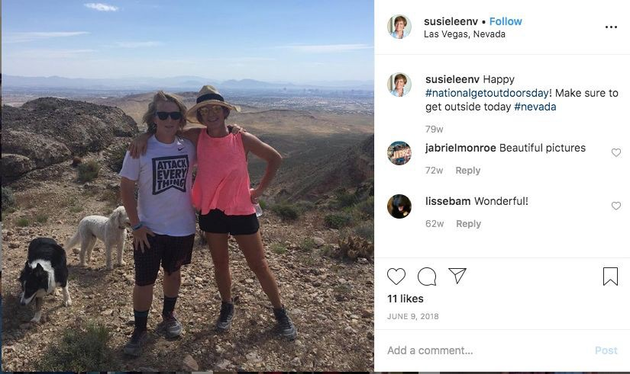

Image 1. Illustrating an image of lower overall quality in terms of lighting, editing, and clarity posted to the “@susieleenv” profile.

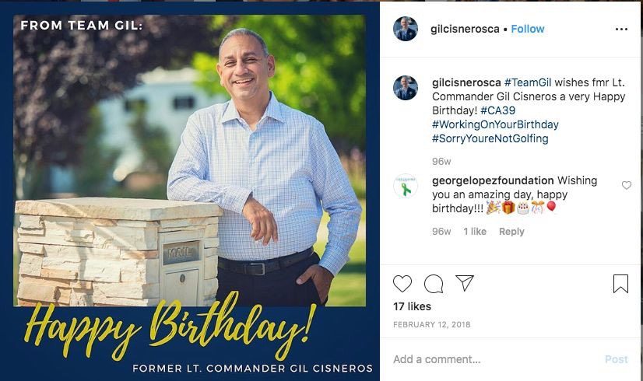

Image 2. Illustrating an image of higher overall quality in terms of lighting, editing, and clarity, in addition to tasteful graphics that are cohesive with the rest of the profile posted to the “@gilcisnerosca” account.
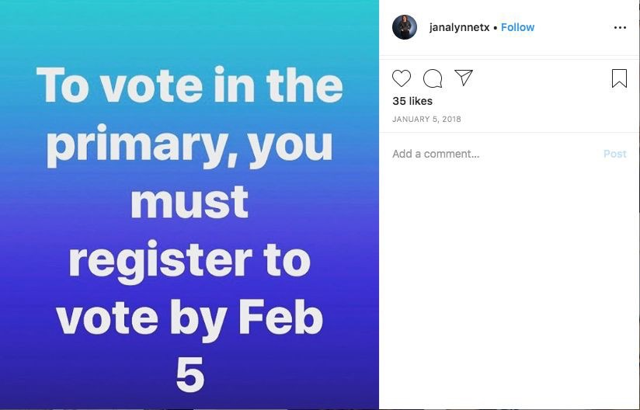

Image 3. Illustrating an edited graphic of lower overall quality and interest posted to the “@janalyneetx” profile.

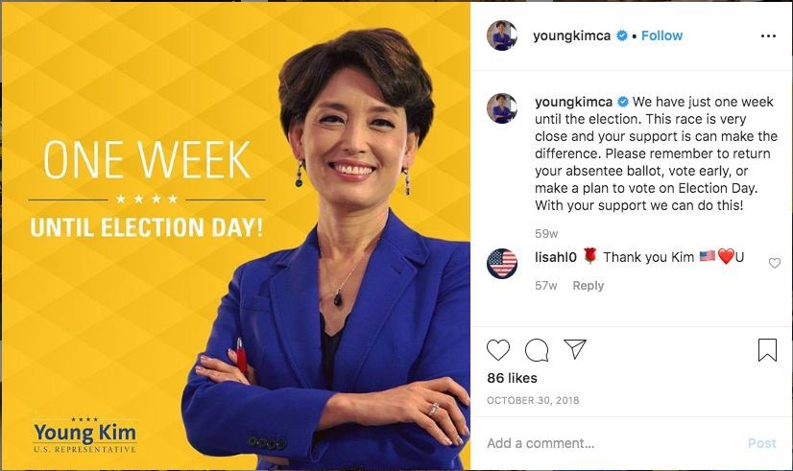

Image 4. Illustrating an edited graphic of higher overall quality and interest posted to the “@youngkimca” profile to juxtapose with Image 3 by “@janalyneetx” account raising awareness about a similar issue.

Endorsements

All candidates, regardless of gender or congressional race, posted regularly about endorsements from local and national figures. These posts included recognizable (and high quality) photos of endorsers, probably encourage recognition of these figures by followers, and were often accompanied by quotes in support of the candidate. To reiterate, there were not many differences here in the inclusion and frequency of endorsement related posts; however, their prominence reinforces the notion that support from the major political party organizations still plays a role in new media.

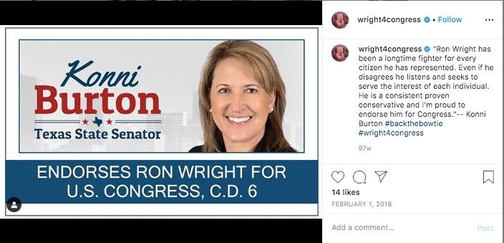

Image 5. Official endorsement by Konni Burton, TX State Senator for the “Ron Wright for Congress” campaign posted to “@wright4congress” profile.
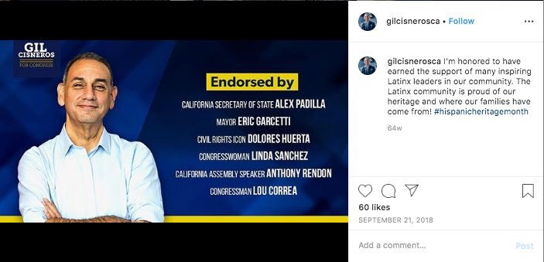

Image 6. Official endorsement image for the “Gil Cisneros for Congress” campaign posted to “@gilcisnerosca” profile.

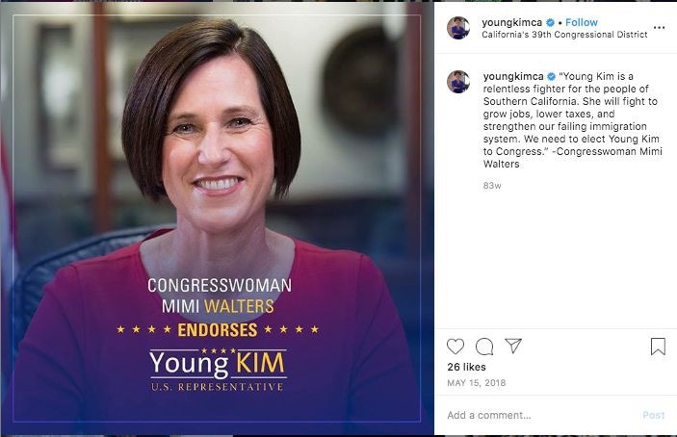

Image 7. Official endorsement by Mimi Walters, former CA Congresswomen, for the “Young Kim for Congress” campaign posted to “@youngkimca” profile.

There was a subcategory that emerged here of pseudo-endorsements which involved a candidate posting a photo of them (selfie or group) with a recognizable political figure (examples include Beto O’Rourke, Joaquin Castro, and Joe Biden) but were not accompanied by any official endorsement of the candidate by that particular figure. These pseudo-endorsements were predominantly and almost exclusively utilized by the female candidates. Which may exemplify a way in which female candidates, who as outlined above, have traditionally received less official party support (hence the number of nonprofits dedicated to providing those resources), are using social media and their ability to control the narrative on such platforms to make up for this lack of traditional forms of support like official endorsements.

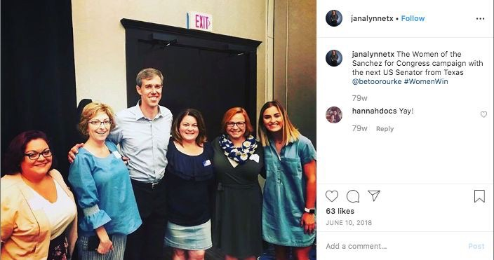

Image 8. Psuedo-endorsement image for the “Jana Lynne Sanchez for Congress” campaign featuring both candidate Snachez and then Senate candidate and future Democratic presidential candidate posted to “@janalynnetx” profile.
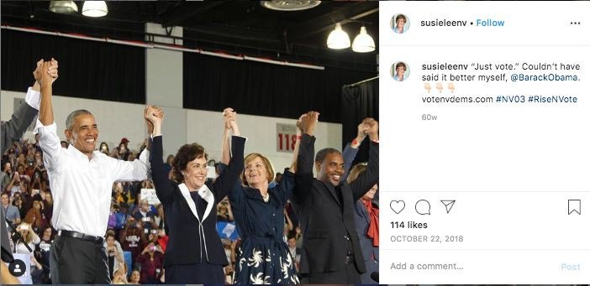

Image 9. Psuedo-endorsement image for the “Susie Lee for Congress” campaign featuring both candidate Lee, Senator and former NV3 representative Jacky Rosen and former President Barack Obama post to the “@susieleenv” profile.

Personal vs. Campaign Content

Another theme that emerged was differences in personal content (examples include posts about children, family, and partners) and directly campaign-related content posts on Instagram. Victorious candidates in all three races stuck to “campaign-only” content, only including family members and such when in group photographs at official events. In contrast, defeated candidates were more likely to post a photo of a pleasant sunset or scenery or about their family and personal life.
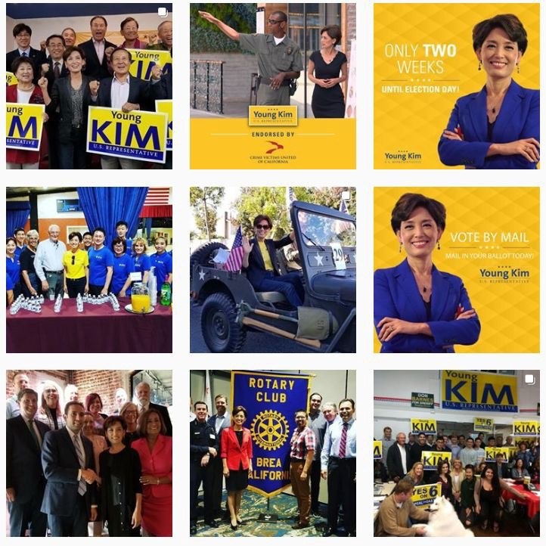

Image 10. Nine photos posted to the “@youngkimca” profile illustrating a “grid” or profile on Instagram that is cohesive and fully campaign focused.

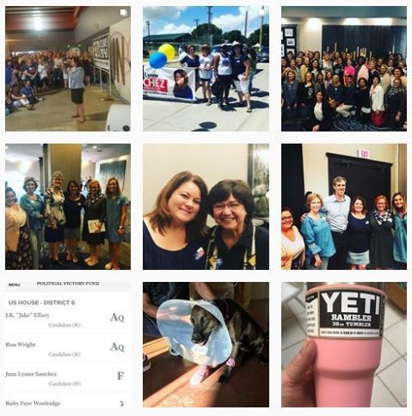

Image 11. Nine photos posted to the “@janalyneetx” profile illustrating a “grid” or profile on Instagram that has a smattering of personal (bottom right photos) and campaign related images (top six photos).

References to Popular Culture

Three candidates, Ronald Wright (R), Danny Tarkanian (R), Jana Lynne Sanchez (D) made several references to popular culture whether in the form of popular trends or important cultural moments. Ronald Wright in Texas’s 6th district posted content related to Colin Kapernick’s scandal with the NFL and often utilized the humorous hashtag, “#backthebowtie” in reference to his oft-worn accessory. Similarly, Danny Tarkanian in Nevada used the popular

“#throwbackthursday” hashtag as motivation for posting content featuring old family photos. Tarkanian also created and regularly “tagged” a separate Instagram account featuring and from the perspective of his family dog, which is a popular online trend amongst people with pets. The candidate who most regularly posted this kind of “popular culture” content was Jana Lynne Sanchez whose profile was littered with “memes” that typically had an accusatory and negative partisan bent. Interestingly, neither candidate in the race for California’s 39th seat made these kinds of references. While these case studies make it difficult to infer anything about male candidates, as both a winner and loser made regular popular references, there was a clear distinction in this kind of content between Jana Lynne Sanchez (D) and Susie Lee (D). In one case, the losing female candidate made what could be considered “aggressive” references to popular culture while the victorious Susie Lee included no such content on her profile.

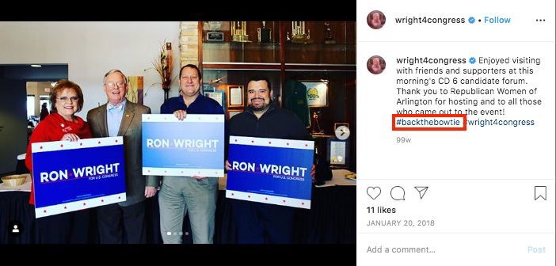

Image 12. Illustrates the use of the humorous “#backthebowtie” hashtag by the “Ron Wright for Congress” campagin accompanying a photo posted to the “@wright4congress” profile.

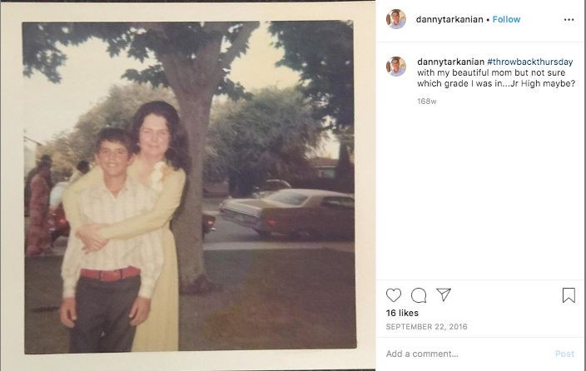

Image 13. Illustrates the use of the “#throwbackthursday” hashtag by the “Danny Tarkarian for Congress” campagin accompanying a photo posted to the “@dannytarkarian” profile.

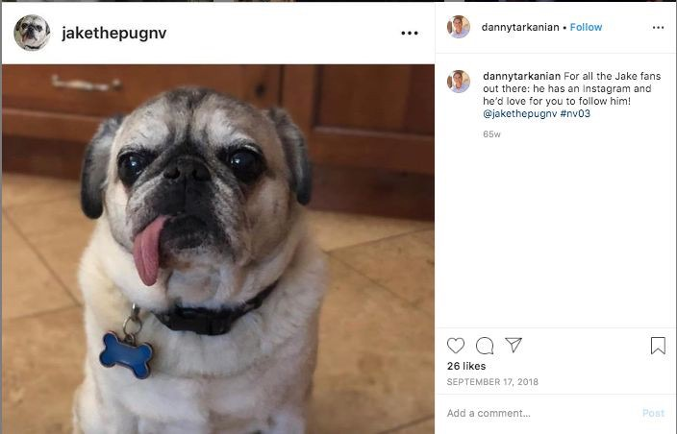

Image 14. Image promoting a separate account solely for the Tarkarian family dog, “Jake the pug” (@jakethepugnv) posted to the “@dannytarkarian” profile.

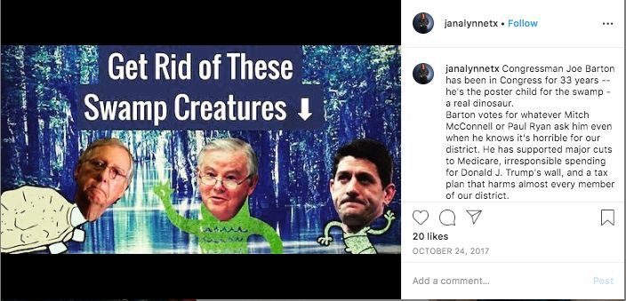

Image 15. A meme posted by the “Jana Lynne Sanchez for Congress” campaign featuring Current Senate Majority Leader Mitch McConnell, Congressman Joe Barton, and Former Speaker of the House, Paul Ryan, as “swamp creatures” posted to the “@janalyneetx” profile.
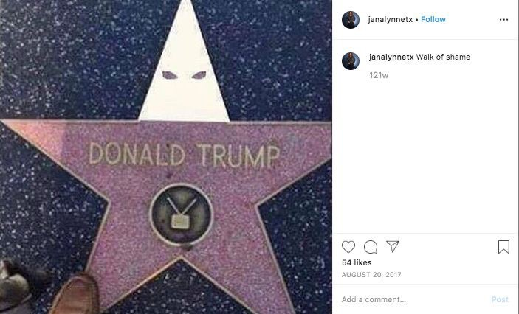

Image 16. A meme posted by the “Jana Lynne Sanchez for Congress” campaign featuring President Donald Trump’s star on the Hollywood Walk of Fame edited to be wearing a white hood associated with the KKK posted to the “@janalyneetx” profile.

Conclusion

At the end of their study, the Atalanta research group concluded that “If used effectively, the benefits of digital campaigning [for female candidates] outweigh the negatives.”124
Women are underrepresented across the globe in politics and while the U.S. has recently made historic strides, the gender gap continues to exist with repercussions that affect the effectiveness of U.S. democracy at every level of governance. The “ambition gap” is the current theoretical model which best explains why and how women continue to be absent from political discussion and to diminish this gap means to address the barriers that have traditionally disincentivized women from entering the political arena. The barrier specifically addressed here is that of the traditional media, whose proven gendered and unequal coverage of political campaigns has supplemented the dissuasion of would-be female candidates from running for seats.
The emergence of social media platforms, included under the umbrella term of “new media,” has not only affected the traditional media structure but also offers a tool for candidates to bypass editorial media with their messaging and exert more influence on the narratives surrounding their campaigns. One of the most commonly cited drawbacks to using social media as such as a tool, particularly for female candidates, has been a lack of how-to and best practices knowledge, without which the running of a campaign social media account can become a waste of precious resources rather than a way to get a leg up. In order to address this drawback and equip female politicians with this kind of knowledge, we must first understand how social media accounts are being used today on the campaign trail. The case studies included here offer a

124 Bethany Wheatley, (Anti)Social Media: The benefits and pitfalls of digital for female politicians.

foundational glimpse into how candidates are currently using the social media platform of Instagram and what tactics, humorous tones, and aesthetic choices resonate with and seem to connect them best with voters. Understanding what aspects of social media, such as having a cohesive, high-quality aesthetic look to posts that reference popular culture, work both in favor and against candidates is the first step to endowing candidates with the knowledge to make these platforms a more effective tool. It is the hope of this work that by disseminating this information, social media can become more of a low-cost tool for candidates to control their own narratives, connect with voters and potential donors far and wide, and ultimately view traditional media as less of an impediment to becoming a political representative. Under the right circumstances and through more effective use, social media has the potential to encourage more women to run for political office and increase female representation both in the U.S. and around the globe.

References

Ancu, Monica. “Here Comes Everybody, or Not: An Analysis of the Social Media Consumer of Campaign Content.” In Presidential Campaigning and Social Media: An Analysis of the 2012 Campaign, edited by John Allen Hendricks & Dan Schill, 218-231. New York: Oxford University Press, 2015.
Anzia, Sarah F., and Christopher R. Berry. “The Jackie (and Jill) Robinson Effect: Why Do Congresswomen Outperform Congressmen?” American Journal of Political Science 55, (2011): 478-493.
Atkeson, Lonna Rae, and Nancy Carrillo. "More is better: The influence of collective female descriptive representation on external efficacy." Politics & Gender 3, no. 1 (2007): 79-101.
Beachum, Lateshia. “Transgender Political Candidates Are Increasingly Common. The Money Backing Them Is Not.” The Center for Public Integrity. March 6, 2019. https://public integrity.org/politics/elections/transgender-political-candidates-are-increasingly-commo
-the-money-backing-them-is-not.
Boulianne, Shelley. "Social media use and participation: A meta-analysis of current research."Information, communication & society 18, no. 5 (2015): 524-538
Burrell, Barbara. Gender in Campaigns for the U.S. House of Representatives. Ann Arbor, MI: The University of Michigan Press, 2014.
Bystrom, Diane. “Gender and Communication on the Campaign Trail.” In Gender & Elections (3rd ed), edited by Susan J. Carroll, and Fox, Richard. L. Fox. New York: Cambridge University Press, 2014.
Carroll, Susan J., and Richard L. Fox. Gender & Elections (3rd ed). New York: Cambridge University Press, 2014.
Chadwick, Andrew, and Jennifer Stromer-Galley. "Digital media, power, and democracy in parties and election campaigns: Party decline or party renewal?." The International Journal of Press/Politics 21, no. 3 (2016): 283-293.
Clements, J. “Number of social network users worldwide from 2010 to 2021(in billions).”
Statista. August, 14, 2019. https://www.statista.com/statistics/278414/number-of-

worldwide-social-network-users/.
Clements, J. “Most popular mobile social networking apps in the United States as of September 2019, by monthly users (in millions).”Statista. Nov. 25, 2019. https://www.statista.com
/statistics/248074/most-popular-us-social-networking-apps-ranked-by-audience/.
Cook, Elizabeth Adell, “Voter Reaction to Women Candidates,” in Women and Elective Office, edited by Sue Thomas and Clyde Wilcox. New York: Oxford University Press, 1998.
Craig, Annemieke. “Theorising about gender and computing interventions through an evaluation framework. Information Systems Journal.” Information Systems Journal 26, no. 6 (2015).
Devine, Tad. “Paid Media in Campaigns - Now and In The Future.” In Campaigns on the Cutting Edge, edited by Richard J. Semiatin, 27-42. California: CQ Press, 2017.
Di Meco, Lucina. Women’s Political Networks. Defining Leadership, Breaking Barriers, and Fostering Change. Washington D.C.: The Wilson Center, 2017.
Di Meco, Lucina. #ShePersisted: Women, Politics, & Power In The New Media World.
Washington D.C.: The Wilson Center, 2019. https://static1.squarespace.com/static/5d ba105f102367021c44b63f/t/5dc431aac6bd4e7913c45f7d/1573138953986/191106+SHE
ERSISTED_Final.pdf.
Dimitrova, Daniela V., Adam Shehata, Jesper Strömbäck, and Lars W. Nord. "The effects of digital media on political knowledge and participation in election campaigns: Evidence from panel data." Communication Research 41, no. 1 (2014): 95-118
Dollar, David, Raymond Fisman, and Roberta Gatti. “Are Women Reall the Fairer Sex?
Corruption and Women in Government.” Journal of Economic Behavior & Organization
46, no. 4 (2001): 423-429.
Effing, Robin, Jos Van Hillegersberg, and Theo Huibers. "Social media and political participation: are Facebook, Twitter and YouTube democratizing our political systems?” International conference on electronic participation, (2011): 25-35.
Enli, Gunn Sara. "Twitter as arena for the authentic outsider: Exploring the social media campaigns of Trump and Clinton in the 2016 US presidential election." European journal of communication 32, no. 1 (2017): 50-61.
Evans, Heather K., Victoria Cordova, and Savannah Sipole. “Twitter Style: An Analysis of How

House Candidates Used Twitter in Their 2012 Campaigns.” Political Science and Politics
47, no. 2 (2014): 454-462.
Evans, Heather K., and Jennifer Clark. “You Tweet Like a Girl!”: How Female Candidates Campaign on Twitter” American Politics Research 44, no. 2 (2015): 1-27.
“Facts on Women of Color in Office.” CAWP (Center for American Women and Politics at the Eagleton Institute of Politics at Rutgers, The State University of New Jersey). Accessed
December 6, 2019. https://www.cawp.rutgers.edu/fact-sheets-women-color
Freeman, Jo. We Will Be Heard: Women’s Struggles for Political Power in the United States.
Lanham, MA: Rowman & Littlefield Publishers, Inc., 2008.
Githens, Marianne, and Jewel L. Prestage. A Portrait of Marginality: The Political Behavior of the American Woman. New York: Longman, 1977.
“The Global Gender Gap Report 2018.” World Economic Forum. Accessed December 6, 2019. https://www.weforum.org/reports/the-global-gender-gap-report-2018.
Hayes, Danny, and Jennifer L. Lawless. Women on the Run. New York: Cambridge University Press, 2016.
Jaeger, Paul T., and Xie, Bo. “Developing Online Community Accessibility Guidelines for Persons With Disabilities and Older Adults,” Journal of Disability Policy Studies 20, no. 1(2008): 55-62.
Kahn, Kim F, “Does Being Male Help? An Investigation of the effects of Candidate Gender and Campaign Coverage on Evaluations of U.S. Senate Candidates,” Journal of Politics 54, no. 2 (1992):497-517.
Kitchens, K. E., and M. L. Swers. “Why aren't there more republican women in congress?
Gender, partisanship, and fundraising support in the 2010 and 2012 elections.” Politics & Gender 12, no. 4 (2016): 648-676.
Kittilson, Miki Caul, and Kim Fridkin. “Gender, Candidate Portrayals and Election Campaigns: A Comparative Perspective.” Politics & Gender 4, no. 3 (2008): 371-392.
Kjaerum, Morten. European Union Agency for Fundamental Rights, Violence against women: an EU-wide survey – Main results. Luxembourg: Publications Office of the European Union, 2014.
Kuta, Sarah. “Women Who Run for Office Inspire Others to Do the Same, Study Suggests.”

Colorado Arts and Sciences Magazine, UC Boulder, 31 July 2018, www.colorado.edu
/asmagazine/2018/07/31/women-who-run-office-inspire-others-do-same-study-suggests. Kurtzleben, Danielle, Sean McMinn, and Renee Klahr. “What It Looks Like To Have A Record
Number Of Women In The House of Representatives.” NPR (National Public Radio). January 4, 2019. https://www.npr.org/2019/01/04/678227272/what-it-looks-like-to-have
-a-record-number-of-women-in-the-house-of-representati.
Ladam, Christina, et al. “Prominent Role Models: High-Profile Female Politicians and the Emergence of Women as Candidates for Public Office.” American Journal of Political Science 62, no. 2 (2018): 369–381.
Lawless, Jennifer. L., and Richard L. Fox. It Takes a Candidate: Why Women Don’t Run for Office. New York: Cambridge University Press, 2005.
Lyon, Jarrett. “A brief history of trans people in elected office.” Salon. November
8, 2017. https://www.salon.com/2017/11/08/a-brief-history-of-trans-people-in-elected
- office/.
Major, Lesa Hately, and Renita Coleman. “The Intersection of Race and Gender in Election Coverage: What Happens When the Candidates Don't Fit the Stereotypes?” Howard Journal of Communications 19, no. 4 (2008): 315-333.
Macharia, Sarah. Global Media Monitoring Project (GMMP) 2015. Toronto: World Association for Christian Communication (WACC), 2015.
McGregor, Shannon C., and Rachel R, Mourão.“Talking Politics on Twitter: Gender, Elections, and Social Networks.” Social Media + Society 2, no. 3 (2016):1-14.
Meeks, Lindsey. “Gendered styles, gendered differences: Candidates’ use of personalization and interactivity on Twitter.” Journal of Information Technology & Politics 13, no. 4 (2016): 295-310.
Merriam-Webster, s.v. “social media,” accessed December 6, 2019, https://www.merriam-webs ter.com/dictionary/social%20media.
Morton, Krystalyn J. “Communicating Food Reform Through Instagram: A Grounded Theoretical Assessment of Dialogic Engagement on Jamie Oliver’s ‘Food Revolution’ Instagram Account.” Master’s thesis, Virginia Polytechnic Institute, 2016.

Murray, Rainbow. “Conclusion: a new comparative framework” in Cracking the highest glass ceiling: a global comparison of women’s campaigns for executive office edited by Rainbow Murray. Santa Barbara, CA: Praeger, 2010.
Norrander, Barbara, and Clyde Wilcox. “Trends in the Geography of Women in the U.S. State Legislatures.” In Women and Elective Office: Past, Present, and Future, edited by Sue Thomas and Clyde Wilcox, 273-287. New York: Oxford University Press, 2014.
“Number of social media users worldwide 2010-17 with forecasts to 2021.” European Commision. https://ec.europa.eu/knowledge4policy/visualisation/number-social-media- Users-worldwide-2010-17-forecasts-2021_en.
Patterson, Thomas E. Social Media: Advancing Women in Politics? Brussels: Women in Parliaments Global Forum, 2016. November 2019, https://www.womeninparliaments
.org/wp-content/uploads/2016/10/WIP-Harvard-Facebook-Study_Oct2016.pdf. “Politics is Personal: Keys to Likeability and Electability for Women.” Barbara Lee Family
Foundation. April 2016. https://www.barbaraleefoundation.org/wp-content/uploads/ BLFF-Likeability-Memo-FINAL-1.pdf.
Reece, Andrew, and Christopher Danforth. “Instagram photos reveal predictive markers of depression.” EPJ Data Science 6, no. 15 (2017).
Ross, Karen. Gender, Politics, News: A Game of Three Sides. Hoboken, NJ: Wiley-Blackwell, 2016.
Sanbonmatsu, Kira. “Political Parties and the Recruitment of Women to State Legislatures.” The Journal of Politics 64, no. 3 (2002): 791-809.
Seltzer, Richard A., Jody Newman, and Melissa Voorhees Leighton. Sex as a Political Variable: Women as Candidates and Voters in U.S. Elections. Boulder, CO: Lynne Rienner, 1997.
Smith, Eric R. A. N., and Richard L. Fox. “A Research Note: The Electoral Fortunes of Women Candidates for Congress.” Political Research Quarterly 54, no. 1 (2001): 205-221.
Towner, Terri L., and Caroline Lego Munoz. “Picture Perfect? The Role of Instagram in Issue Agenda Setting During the 2016 Presidential Primary Campaign.” Social Science Computer Review 36, no. 4 (2016):494-499.
Tracy, Sarah J., “Data analysis basics: A pragmatic iterative approach,” in Qualitative Research

Methods: Collecting Evidence, Crafting Analysis, Communicating Impact (Malden, MA: John Wiley & Sons, Inc.), 183- 202.
Kjaerum, Morten. European Union Agency for Fundamental Rights, Violence against women: an EU-wide survey – Main results. Luxembourg: Publications Office of the European Union, 2014.
Troll Patrol. London: Amnesty International, 2018.
“U.S. Census Bureau QuickFacts: United States.” Census Bureau QuickFacts. U.S. Census Bureau. Accessed December 15, 2019. https://www.census.gov/quickfacts/fact
/table/US/LFE046217.
Wallack, Lawrence M. "Mass media campaigns: The odds against finding behavior change."
Health Education Quarterly 8, no. 3 (1981): 209-260.
Ward, Janabeth. “A Content Analysis of Celebrity Instagram Posts and Parasocial Interaction.”
Elon Journal of Undergraduate Research in Communications 7, no. 1 (2016).
Wheatley, Bethany. (Anti)Social Media: The benefits and pitfalls of digital for female politicians.
Warwickshire, England: Atalanta, 2018. https://static1.squarespace.com/static/595411 f346c3c48fe75fd39c/t/5aa6fa310d9297a484994204/1520892494037/%28Anti%29Socia
_Media_Report-FINAL2-lowres.pdf.
Williams, Blair. “He’s “taken back the reins” and she’s “a backstabbing murderer”: a comparative media analysis of the Prime Ministerial ascension of Julia Gillard and Malcolm Turnbull.” Australian Journal of Political Science 52, no. 4 (2017): 550-564.
Willis, Amanda, Jacque Smith, and Casey Hicks. “All the countries that had a woman leader before the U.S.” CNN Politics. January 28, 2019. https://www.cnn.com/interactive
/2016/06/politics/women-world-leaders/.
Wolbrecht, Christina, and David E. Campbell. “Role models revisited: youth, novelty, and the impact of female candidates.” Politics Groups, and Identities 5, no. 3 (2016): 418-434.
“Women In State Legislatures for 2019.” National Conference of State Legislatures, 14 Feb. 2019. http://www.ncsl.org/legislators-staff/legislators/womens-legislative-network
/women-In-state-legislatures-for-2019.aspx.
Yarchi, Moran, and Tal Samuel-Azran, “Women politicians are more engaging: male versus

female politicians’ ability to generate users’ engagement on social media during an election campaign.” Information, Communication & Society 21, no. 7(2018):978-995.

