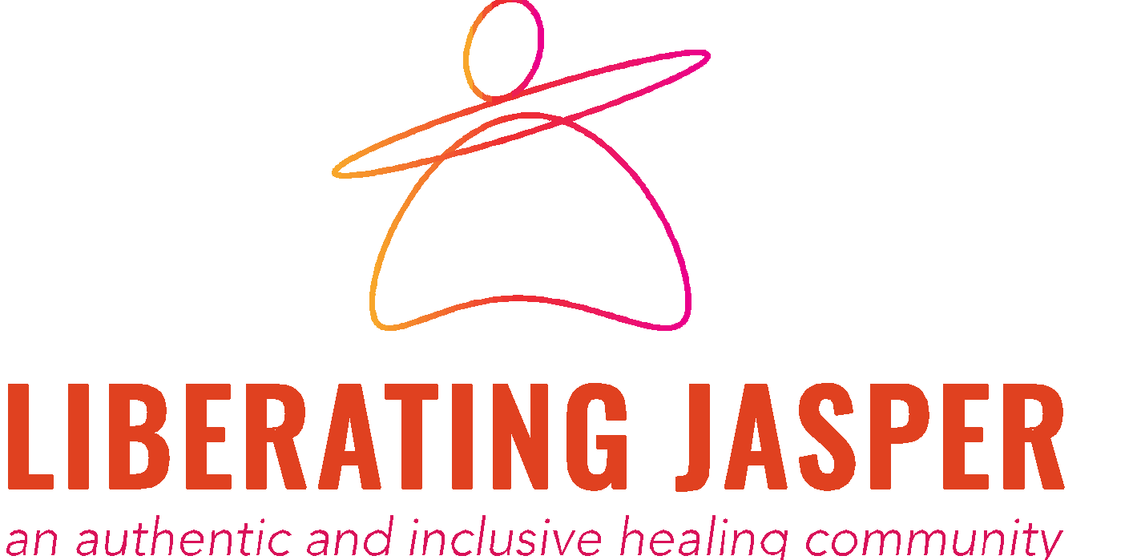

Day of Wellness Workshop
Body Liberation & Food Reclamation

Resources:

Books
* Health at Every Size: The Surprising Truth About Your Weight by Lindo Bacon
* Body Respect by Lindo Bacon & Lucy Aphramor
* Anti-Diet by Christy Harrison
* The Body is Not an Apology by Sonya Renee Taylor
* Fearing the Black Body: The Racial Origins of Fat Phobia by Sabrina Strings
* Fat Girls in Black Bodies by Joy Cox

Podcasts
* Maintenance Phase
* Fresh Out the Cocoon
* Food Heaven
* Food Psych
* Love Curvy Yoga

HAES aligned gyms, classes
* Ascent Gym, Tacoma
*Joyn, online (free)

