BioRad Real Time PCR Detection System
User Guide
University of Puget Sound
August 2011

Table of Contents

A. Real-Time PCR.............................................................................................................................................. 1
B. Safety Considerations and Responsible Equipment Use......................................................................... 1
C. Disclaimer! ................................................................................................................................................... 1
D. Operation and Use of the Real-Time PCR Machine.............................................................................. 2-17
- Start-up Procedures.............................................................................................................................. 2
- Primer Design and Reaction Set-up................................................................................................. 2-4
  - SYBR Green reactions................................................................................................................... 2-3
    - SYBR Green technology.................................................................................................... 2-3
    - Rules for primer and amplicon design................................................................................... 3
  - TaqMan probe reactions................................................................................................................... 3
    - TaqMan technology............................................................................................................... 3
    - Rules for primer/probe set design......................................................................................... 3
  - Other assays..................................................................................................................................... 3
  - Reaction set-up................................................................................................................................. 4
- Reagents and volumes.......................................................................................................... 4
- Introduction to Plate Set-up, the Software, and Running Your PCR Assay............................... 4-15
  - Creating a run................................................................................................................................. 4-5
    - Opening the software.......................................................................................................... 4-5
    - Setting up the run conditions.................................................................................................. 5
  - Protocol setup and design............................................................................................................... 6-9
    - Steps (SYBR Green-based assays)....................................................................................... 6
- Typical protocol example........................................................................................................ 6
    - Temperatures (SYBR Green-based assays).......................................................................... 6
    - Setting up your assay in the Protocol Editor........................................................................ 6-9
- Adding and deleting steps...................................................................................................... 7
- Modifying temperature or time................................................................................................ 7
- Inserting a gradient or melt curve........................................................................................ 7-8
- Saving your protocol............................................................................................................... 9
  - Plate Setup.................................................................................................................................... 9-14
    - Setting up your plate in the Plate Editor.......................................................................... 10-14
- Plate Loading Guide......................................................................................................... 10
- Labeling sample type and targets............................................................................... 11-12
- Setting up replicates and standards............................................................................ 12-13
- Options found in the Experiment Settings window...................................................... 13-14
  - Starting the Assay Run..................................................................................................................... 14
  - Run Completion Output............................................................................................................... 14-15
- Data output example.................................................................................................................. 15
- Assay Validation and Optimization............................................................................................... 15-17
  - Optimization of annealing temperature....................................................................................... 15-16
    - Inserting a temperature gradient and experimental design.................................................. 15
    - Analyzing the melt curve and C_{T} value, and determining optimal temperature............... 15-16
  - Optimization of primer concentration................................................................................................ 16
    - Setup of primer concentration optimization assays.............................................................. 16
    - Analyzing the melt curve and C_{T} value, and determining optimal concentration.................. 16
  - Standard curves: calculation of PCR efficiency to measure assay performance............................ 16
  - Optimization of TaqMan probe reactions.......................................................................................... 17
- Relative Quantification........................................................................................................................ 17
- Absolute Quantification....................................................................................................................... 17
A. Real-Time PCR

In contrast to conventional PCR, in which the final product is detected by end-point analysis on agarose gel, real-time PCR allows the detection of the amplified product in “real time”, as the product accumulates. This is made possible through the use of fluorescent reporter molecules in the reaction. This method has major advantages over conventional PCR, the most significant of which is the quantitative analysis of starting template (hence, the term qPCR).

B. Safety Considerations and Responsible Equipment Use

Primary safety concerns with the Real-Time machine have to do with the high temperatures of the heating block. The thermal cycler generates high heat that can cause serious burns. Always allow the sample block to return to normal temperature before opening the lid and removing samples. Use caution when touching the sample block.
This instrument must be used with care. Pay attention to labels on the instrument; in particular, the lid must always be opened either by pushing the button on the front of the lid, or through the computer software. NEVER force the lid open. This may result in damage to the machine.

C. Disclaimer!

Please note: this is an abbreviated guide. The actual manual for this instrument + software package is over 150 pages. While it is a good exercise for any student to read the user manual when beginning work on a new instrument, this User Guide can serve as a guide to general use of the instrument and may be sufficient for many uses. However, in the event that you encounter trouble, need more information, or require assistance, contact Amy (email: areplogle@pugetsound.edu; location: Room 127E, Harned Hall; phone: 253-879-2829) or refer to the manual for the instrument or software. The manual and applications guide provided by BioRad for this instrument is quite good, and frequent users should familiarize themselves with these booklets both for a review of PCR concepts and for help with troubleshooting.

D. Operation and Use of the Real-Time PCR Machine

Students should always have training on the Real-Time PCR machine prior to use! To set up a training session on how to operate the microscope, or for assistance or troubleshooting, please see Amy in Harned Hall Room 127E (areplogle@pugetsound.edu or 253-879-2829).

- Start-up Procedures

To turn the machine on, switch the power switch on the back of the cycler. Then, start up the computer. Open the BioRad CFX96 Manager software on the desktop to start setting up your run. Do not forget to log in on the sign-in sheet next to the machine.

- Primer Design and Reaction Set-up

Before beginning work on the real-time PCR machine, you must first design your primer or primer/probe sets and validate and optimize your reactions. This section of the User Guide discusses primer design.

  - SYBR Green reactions

    - SYBR Green technology
SYBR Green is a DNA-binding dye that fluoresces upon binding to dsDNA. In reactions using SYBR Green (or the new BioRad version, SsoFast EvaGreen), primer pairs are used without probes, which decreased the cost of experiments. Furthermore, since SYBR Green dyes only fluoresce when bound to dsDNA, melt-curves to determine the specificity of reactions can be utilitzed. For more information on SYBR Green technology, consult the Real-Time PCR Applications Guide.
    - Rules for primer and amplicon design
- Design primers that have a GC content of 50–60%. G–C bonds contribute to the stability of primer-template binding, and raise the T_{m}. Also, a GC content of ~50-60% will help to reduce the formation of secondary structures.
- Strive for a melting temperature (T_{m}) between 50 and 65°C. One way to calculate T_{m} values is by using the T_{m} calculator in the BioRad software included with the Real Time machine.
- Use primer sequences that are between 18 and 24 bases.
- Avoid repeats of Gs or Cs longer than 3 bases.
- Place Gs and Cs on ends of primers.
- Check the sequence of forward and reverse primers to ensure no 3' complementarity (avoid primer-dimer formation).
- Verify specificity using tools such as the Basic Local Alignment Search Tool (BLAST) (http://www.ncbi.nlm.nih.gov/blast/). Primer design can be aided using any simple internet site (PrimerBlast and others, any will work; I especially like designing using this program: http://frodo.wi.mit.edu/primer3/, and then verifying specificity with the ncbi Primer BLAST program).
- Plan to amplify a 75–200 bp product. Short PCR products are typically amplified with higher efficiency than longer ones; but a PCR product should be at least 75 bp to easily distinguish it from any primer-dimers that could potentially form.
- In choosing the amplicon, try to avoid templates with long (> 4) repeats of single bases.

  - TaqMan probe reactions

    - TaqMan technology
In TaqMan reactions, sequence-specific primers are used in conjunction with a fluorescently-labeled oligonucleotide probe, which binds to the target sequence during annealing. Specific polymerases (Taq polymerases) displace and cleave the probe, freeing the 5’ fluorescent reporter and producing a fluorescent signal that is detected by the instrument. The use of TaqMan primers/probes is advantageous since these reactions have high specificity, high signal-to-noise ratios, and the capability for multiplexing. However, primer/probe set design is not as straight forward, and initial assay set up may be more expensive than conventional SYBR Green assays.
    - Rules for primer/probe set design
- Primers are typically developed according to the same guidelines as for SYBR Green reactions as outlined in Section 2.1.2.
- Probe design is costly, and it is recommended that primers be validated first, before attempting probe design and validation. In probe design, the probe should:
  - have a T_{m} of 5–10°C higher than the primers
  - be less than 30 nucleotides in length
  - not have a G at the 5’ end (this could quench the fluorescent signal)
  - have a GC content of 30–80%
  - anneal to a template which has more Gs than Cs (such that the probe has more Cs than Gs.
- Consult Table 2.1 on page 24 of the Real-Time PCR Applications Guide in order to choose appropriate Reporter and Quencher combinations.

  - Other assays

A variety of other reaction types have been designed to assist in or improve upon specific applications. To read more about these additional applications, see Section 2.2.2.2 of the BioRad Real-Time PCR Applications Guide.

  - Reaction set-up

For SYBR Green reactions using SsoFast EvaGreen master mix, follow the protocols that accompany the master mix kit. While the amount of master mix you use will be fixed (the EvaGreen master mix is 2x, so for a 20 µL reaction volume, you will use 10 µL), the amount of primers, nuclease-free water, and DNA template will vary. Use the following table to set up your reactions:

Reagent | Volume Per Reaction | Final Concentration
SsoFast EvaGreen supermix | 10 µL | 1x
Forward Primer | Varies | 300–500 nM
Reverse Primer | Varies | 300–500 nM
RNase/DNase-free Water | Varies | --
DNA Template | Varies | --
Total Volume | 20 µL | --

The optimal primer concentration will need to be determined empirically for each primer set (though generally, 500 nM concentration is appropriate), and the amount of DNA template will also vary, but it is suggested to start with an input of cDNA that corresponds to 50 ng to 50 fg total RNA or 50 ng to 5 pg genomic DNA, depending on the target.

For most accurate replication, first pipette the correct volumes of supermix, primers, and water into a microfuge tube (one tube for each target gene or each set of primers), mix, and add the appropriate volume to the bottom of each well of the qPCR plate (or strip). Then, add the DNA template to each well, centrifuge the plate (1000 rpm for 3-5 min is sufficient) to remove bubbles and assure that all of the components are mixed at the bottom of the well, and place the plate (or strip) in the machine [NOTE: to open AND close the lid of the machine, use the correct button in the software (under the Start Run tab of the Run Setup window), or push the button on the front of the machine; DO NOT try to force the lid open as this can break the machine!]. Be sure to pipette carefully and accurately, and be sure that all of the components are completely thawed and mixed well before use.

With this instrument, assay volumes can be miniaturized to as little as 10 µL. However, be aware that pipetting must be even more accurate when smaller volumes are used.

- Introduction to Plate Set-up, the Software, and Running Your PCR Assay

In this section, the plate set-up and software will be introduced, and how to run your assay on the instrument will be detailed. More details will be given in additional sections for use with specific applications.

  - Creating a run

    - Opening the software
Open the software by clicking on the Bio-Rad CFX Manager icon on the desktop.

Upon opening the software, the following screen will open:

    - Setting up the run conditions
To start a new run, select the Create a new Run checkbox. The Run Setup window will then open, with the Protocol tab selected. Here, you will set up the cycling conditions for your run. Below is the default screen with a preset protocol, CFX_2stepAmp.prcl, loaded. Your protocol will vary depending on assay conditions, primers, and target, among other factors.

At this point, you can either create a new protocol, or work off of an existing protocol and modify it according to your specific assay.
- To create a new protocol, select Create New. This will open the Protocol Editor window.
- To load an existing protocol, either select the protocol from the Express Load tab or choose Select Existing to open a protocol saved in a different location (the name of the selected protocol will appear under the Selected Protocol box, and a preview of the selected protocol file will load in the preview window), then click the Edit Selected button to open the Protocol Editor window.
- See section 3.2 – Protocol setup and design – for details on setting up your protocol in the Protocol Editor.

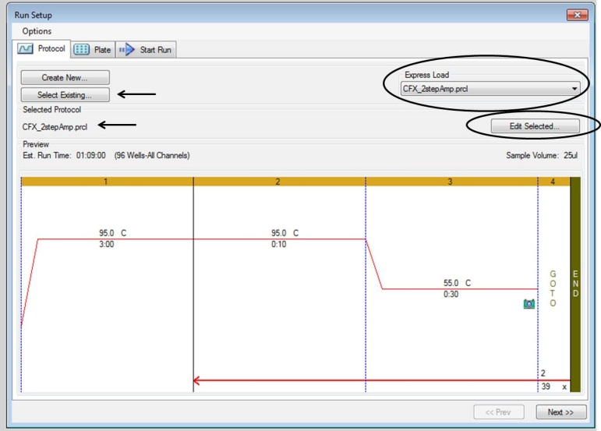

Alternatively, if you have been using the software, but want to start a new run without closing and reopening the software, click the Startup Wizard icon located on the toolbar. This will open the initial Startup Wizard box, and you can begin with creating a new run.

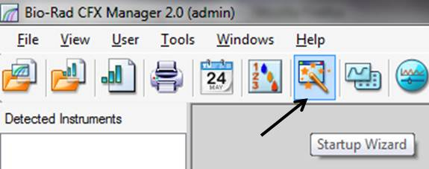
  - Protocol setup and design

    - Steps (SYBR Green-based assays)
The following steps are usually included in a qPCR protocol:
- Initial template denaturation and enzyme activation. Standard conditions call for a single set of 95°C for 30 s on this instrument (for cDNA or plasmid DNA).
- Cycles of 2 steps (up to 45 cycles): denaturation of template and then annealing/extension. Standard protocols call for 95°C for 1–5 s followed by 55–60°C for 1–5 s, for 30–45 cycles.
- Melt curve. This extra step only adds a few minutes to the entire run and should be included in all assays in order to assess the validity of the assay. Typically, the temperature will be increased by 0.5°C for each 2–5 s step (from 65°C to 95°C).

A typical qPCR protocol for this instrument is shown below.

    - Temperatures (SYBR Green-based assays)
- In general, the initial enzyme activation step (step 1 in the image above) will run at 95°C for assays using cDNA or plasmid DNA templates. For genomic DNA templates, this step should be run at 98°C for 2 min.
- Similarly, the denaturation step (step 2 in the image above) should be run at 95°C for cDNA/plasmid DNA or at 98°C for genomic DNA.
- The optimal annealing temperature (step 3 in the above image) must be determined empirically for each primer set and is one of the most important variables in run optimization. See section 4.1, Optimization of annealing temperature, for details on this crucial optimization step. Typically, this step will be run at 55–65°C, depending on the primer set.
- The melt curve is generally run from 65–95°C, increased in increments of 0.5°C (step 5 in the above image).

    - Setting up your assay in the Protocol Editor
As described above, the Protocol Editor window (below) will open when you select Create New or Edit Selected on the Protocol tab of the Run Setup window.

- Input your sample volume in the “Sample Volume” textbox at the top of the window.
- The buttons on the left (Insert Step, Insert Gradient, etc.) are used to add or delete steps from the protocol.
- To modify the temperature or time for any step, click on the step in the window (either the large outline on top, or the summary written below) and simply type in the new time or temperature. Alternatively, you can right click on the step and choose “Step Options.” The following window will pop up, allowing you to make modifications as necessary:

- Note that the temperature is given in degrees Celsius and time is written as min:sec (i.e., 3:00 means 3 min, while 0:30 means 30 s).
- The “Insert Gradient” button can be used to run the rows of the plate at different, progressively-increasing temperatures. This is necessary for optimization of primer annealing temperatures, and may be useful if you wish to run 2 primer sets at different temperatures on the same plate. Alternatively, you can right-click on an existing step, select “Step Options,” and insert a temperature range into the “Gradient” textbox to set up your gradient. Upon clicking the “Insert Gradient” button, or when a gradient step is highlighted, the details of the gradient show up on the right side of the screen:

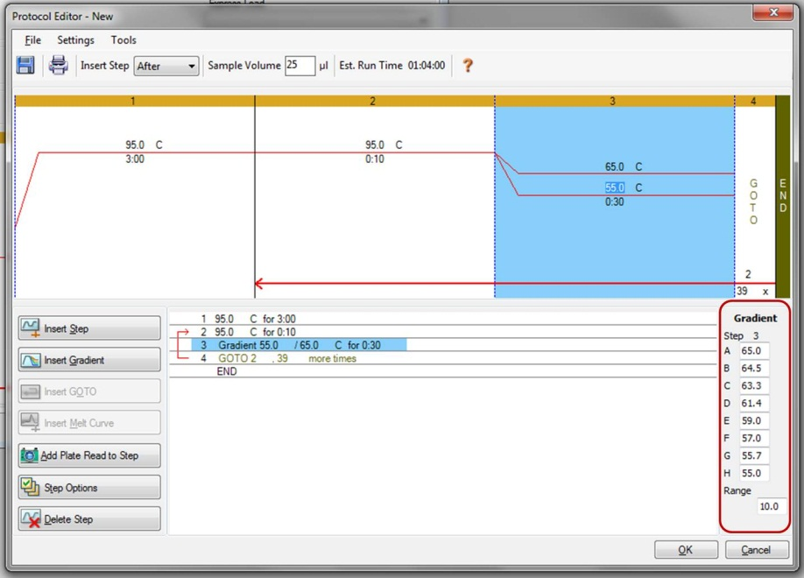

- As with any other step, the temperature of the gradient is changed by typing into the correct box. The gradient range can be changed in the textbox on the right hand side. Also, modifications to the temperature can be input into the right-hand side textboxes, and the top and bottom temperatures will automatically adjust if a new temperature is entered into the middle row designation.
- The GOTO step is used to set up the cycles. The default setting is at 39 cycles, which may be sufficient for many cases. However, this number can easily be changed by selecting the number of cycles and typing in a new number. The red arrow indicates where the protocol will cycle back to when the GOTO step is reached.
- For real-time detection, a plate read should be included right before the GOTO step. Though default settings should include this plate read, if you modify or delete and add steps, the plate read may be removed. Thus, be sure that the step before the GOTO step includes a plate read, indicated by a small camera icon. If the icon is not present, click the “Add Plate Read to Step” button.

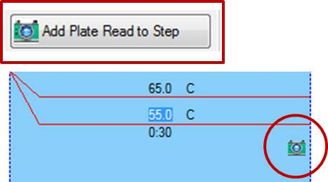

- Finally, select the GOTO step, and the click “Insert Melt Curve” to include a melt curve in your protocol. This is a necessary step for optimization, but also as quality control for all your assays. The temperature gradient, time, and plate read features should be automatically inserted after the GOTO step.

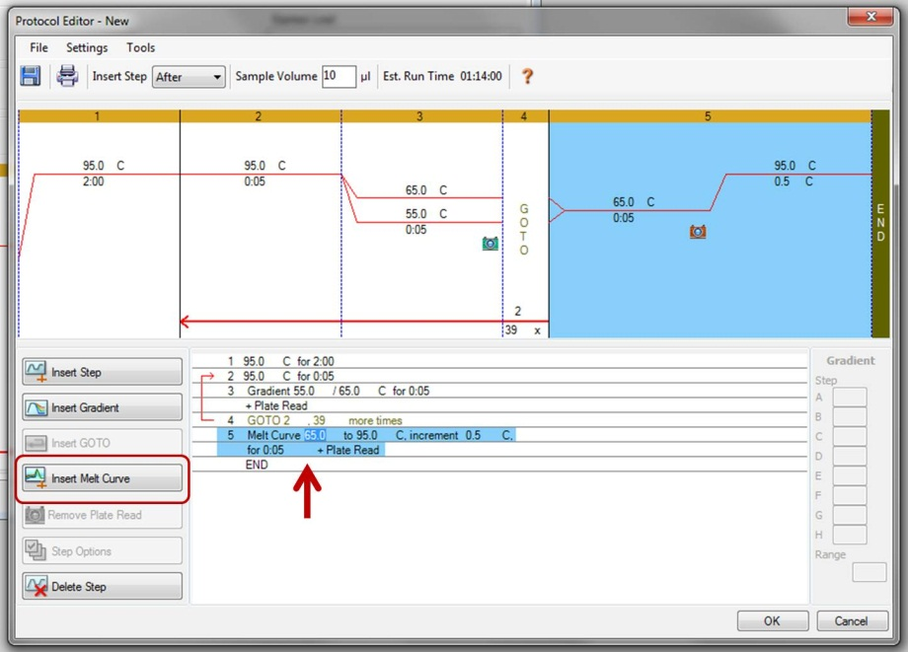

- To finalize the protocol, click “OK,” and then input a file name to save your protocol (if you began with “Create New”; otherwise, clicking save will override the previous protocol with your modifications). If you save the protocol in the “Express Load” folder, it will appear in the pull-down box on the top right of the main Run Setup window.

- Click the “Next” button at the bottom right of the window, or the “Plate” tab at the top of the screen to move on.

  - Plate Setup

NOTE: Plate setup can be done WHILE the assay is reading, since the machine automatically reads ALL wells. You can simply ensure that your fluorophore channel is on (select an express load plate that indicates ALL CHANNELS in the Scan Mode setting), and click the “Next” button at the bottom right or the “Start Run” tab at the top to begin the run. This significantly decreases the total time that it will take you to run your assay, since setting up the plate may take a while. The following section details how to set up your plate before starting the run; however, this all also applies to setting up the plate while the run is in progress.

As with the Protocol tab, in the Plate tab, you can either choose to create a new plate (click “Create New”), select an existing plate (click “Select Existing…”), load an express load plate (select the appropriate plate from the pull-down menu), or edit the selected plate (click “Edit Selected…”).

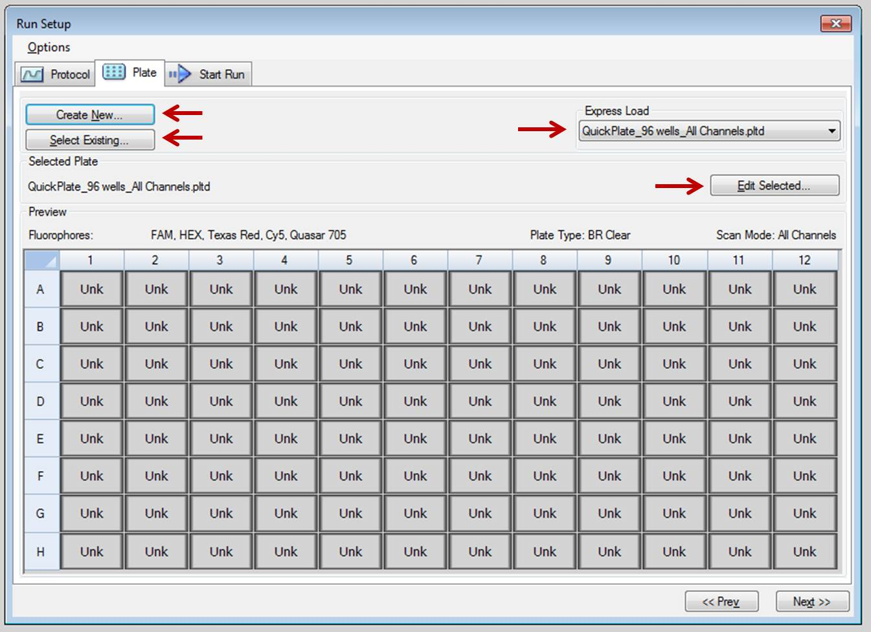

    - Setting up your plate in the Plate Editor

If you click on the “Create New” button or open the Plate Editor during an assay run, the Plate Editor window will appear. A blank/cleared plate looks like this in the Plate Editor:

- There is a quick tool located at the top right of the window, called the Plate Loading Guide. This button brings up a mini-checklist to work you through the steps and can be helpful if you have not used the machine in a while and need a refresher!

- First, click on the Select Fluorophores button in the upper right. For SYBR Green-based assays, the only fluorophore you need checked is SYBR (see image below). Click OK.

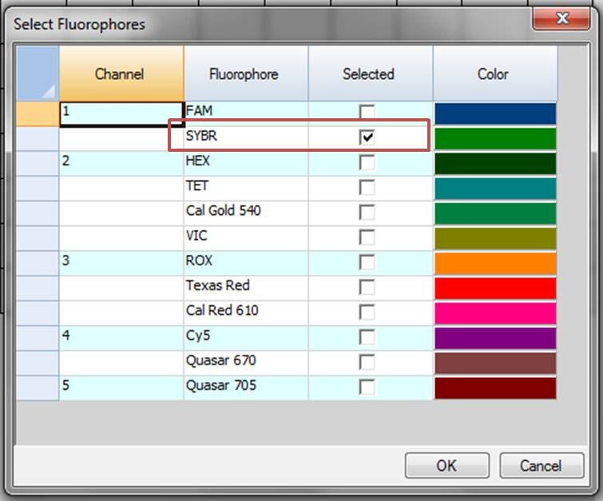

- Next, select the wells you wish to label and choose the Sample Type dropdown box. Select the sample type (example: Standard, Unknown, No Template Control, etc). In the example plate below, I have labeled 2 rows as Unknowns, 2 rows as Standards, and 3 wells as No Template Controls.

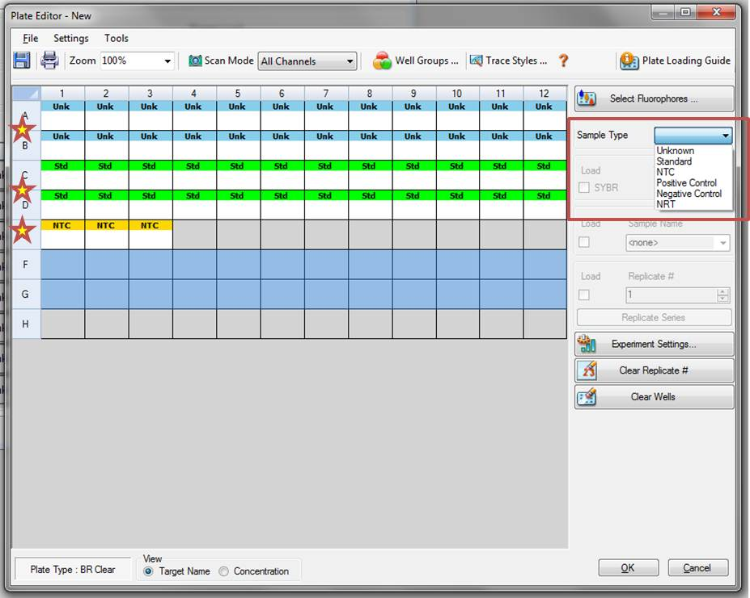

- After setting the Sample Type, you should next load the target name for each well. Start by selecting the wells you wish to label, then choose or type the target name into the Target Name box and hit Enter. All wells that are labeled by Sample Type must have a Target or SYBR label as well. In the example below, I have labeled rows A and C as Test Gene1 and rows B and D as Test Gene2.

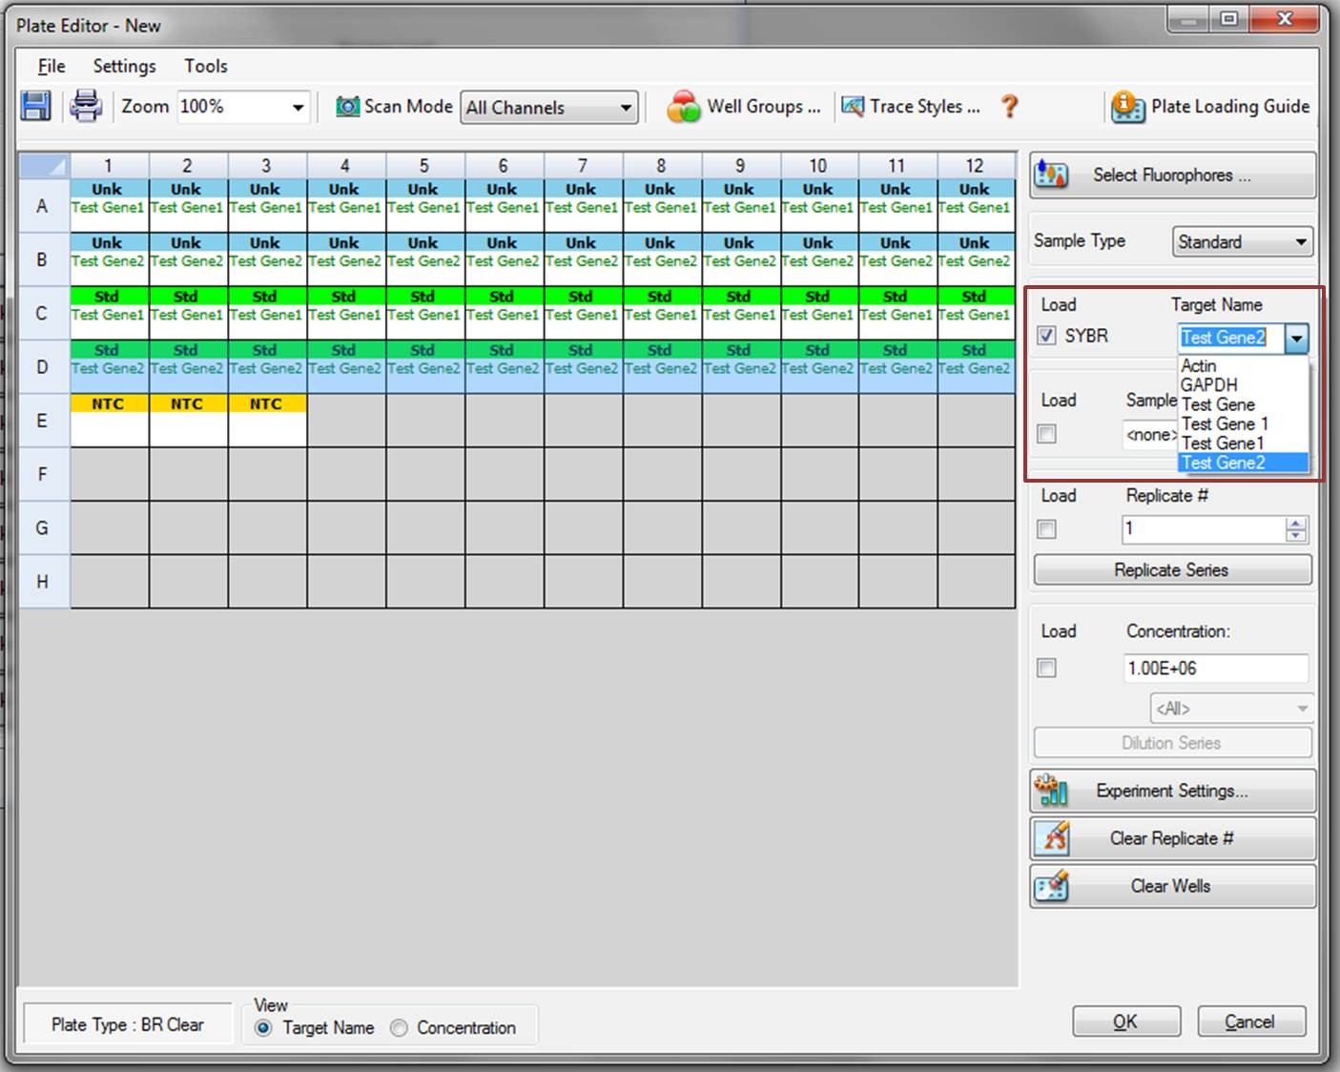

- Next, you can label wells as replicates and load additional sample name information. To input the sample name, select the wells you wish to label, type the sample name into the Sample Name box, and hit Enter. In the example below, I have labeled WT (wild-type) and MT (mutant) at 2 time points (4 h and 12 h) for the Unknown wells in rows A and B.
- To designate replicates, select all the wells you wish to designate (multiple samples at once), then click the Replicate Series button. Input your Replicate Size (most commonly you will run samples in triplicate, so the replicate size will be 3). If necessary, indicate the Starting Replicate number and whether your samples are run horizontally or vertically. Click Apply. In the example below, I have labeled horizontal replicates for the Unknown wells in rows A and B.

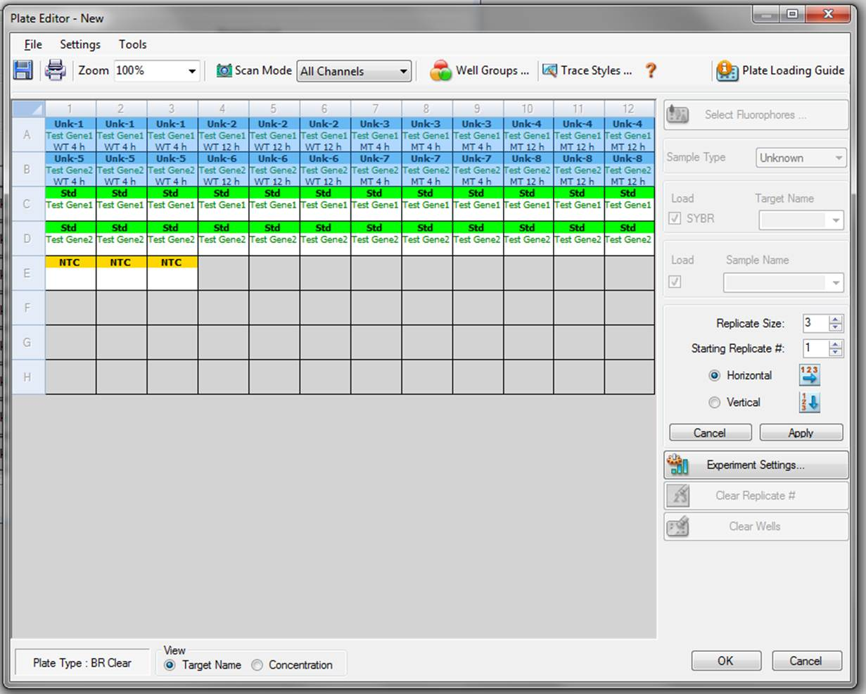

- When running a Standard Curve, first set the Standard Wells as replicates as described above. Then, select the Std wells for a single target and click the Dilution Series button. Unless you are testing a specific, known quantity of your starting template, the Starting Concentration is somewhat arbitrary. Just assure that the correct Dilution Factor is included, and that the Decreasing box is checked (as applicable for your samples). Click Apply. In the below example, I have labeled rows C and D as 2 separate Standard Curves, with each having 4 10-fold dilutions of template, run in triplicate.

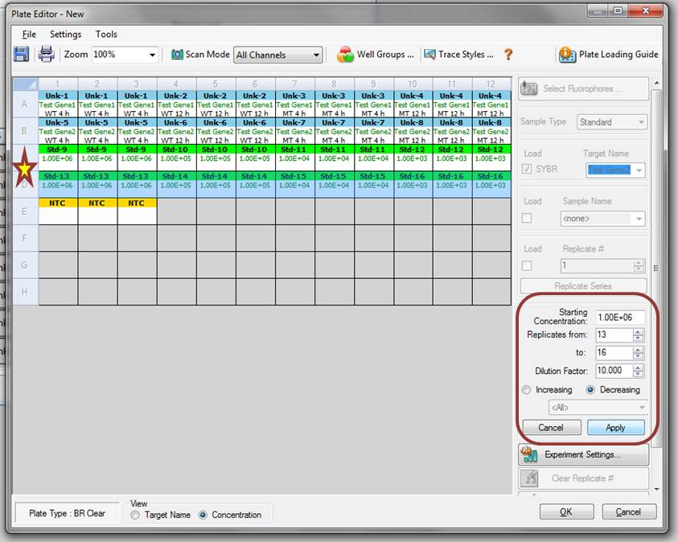

- In the Experiment Settings window, you can set your reference target and input the PCR Efficiency values for your primer pairs, among other options. Click on the Experiment Settings button to begin.
  - For quantitative experiments, a reference/housekeeping gene is required. Click the appropriate checkbox to select your reference gene. In the example below, I have indicated GAPDH as the reference.
  - You can change the color that each gene target will be labeled with by clicking on the colored rectangle for each gene. Choose something that is easy to see against a white background.
  - If the Show Analysis Settings box is checked, you will be able to edit the PCR Efficiency for each target (primer set). Uncheck the “Auto Efficiency” box and then type the Efficiency % into the appropriate box. Click OK. If no efficiency % is indicated, the software will automatically default to 100% efficiency. It is imperative to have PCR efficiencies calculated for each primer pair on a regular basis (once every couple of months is sufficient) for quantitative assays (See Section 4.3: Standard curves). In the below example, I have set the efficiency for GAPDH at 102%.

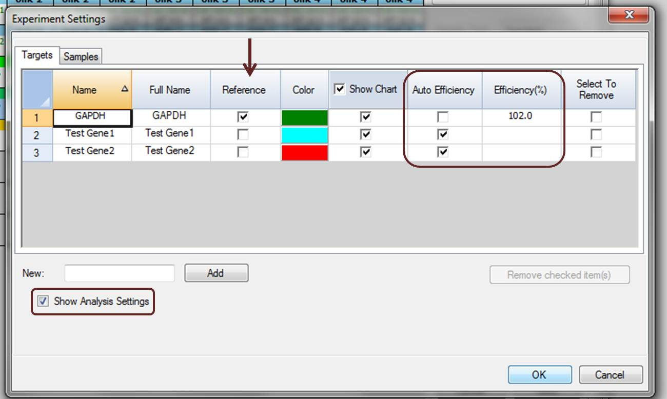

  - Starting the Assay Run

Clicking the “Next >>” button on the Plate tab will open the Start Run tab. If you have not already, click the Open Lid button, arrange your plate (or strips) in the block, and then click Close Lid. Finally, click Start Run to begin the PCR protocol and plate reads.

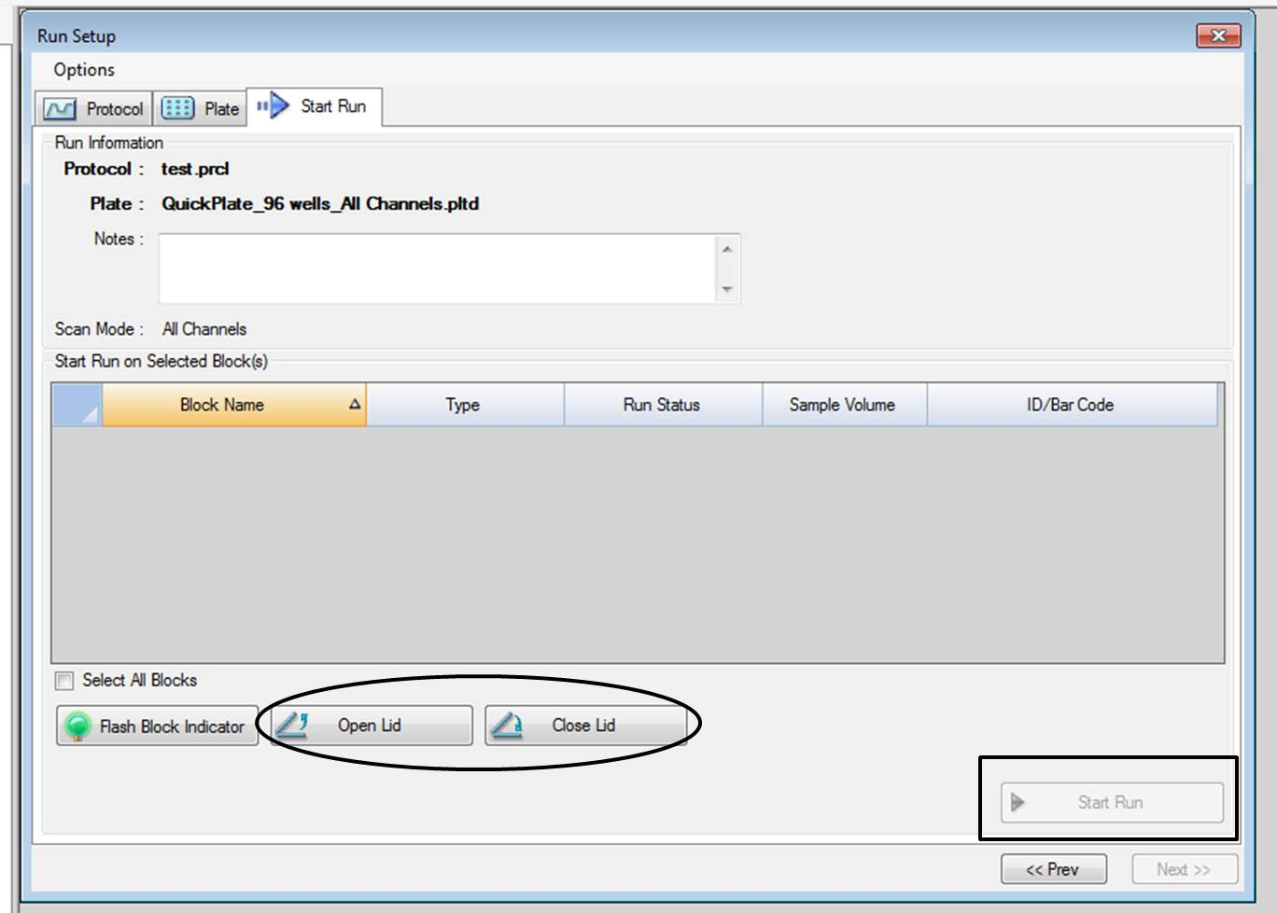

  - Run Completion Output

During assay run, the approximate time left and the real-time amplification plot will show up on the screen. When the assay is finished running, the Data Analysis screen will open. The data is automatically saved as a data (.pcrd) file, or you can re-save it under a different name/location (File >> Save As…).

The Data Analysis window can be used to view and analyze your data, create output reports (click the Reports button to save as a .pdf file), create and copy graphs, get information from melt curves and standard curves, view quantification data, etc. Below is a sample Custom Data View of a gene expression experiment, including an Amplification Plot, Gene Expression graph, and Melt Peak analysis.

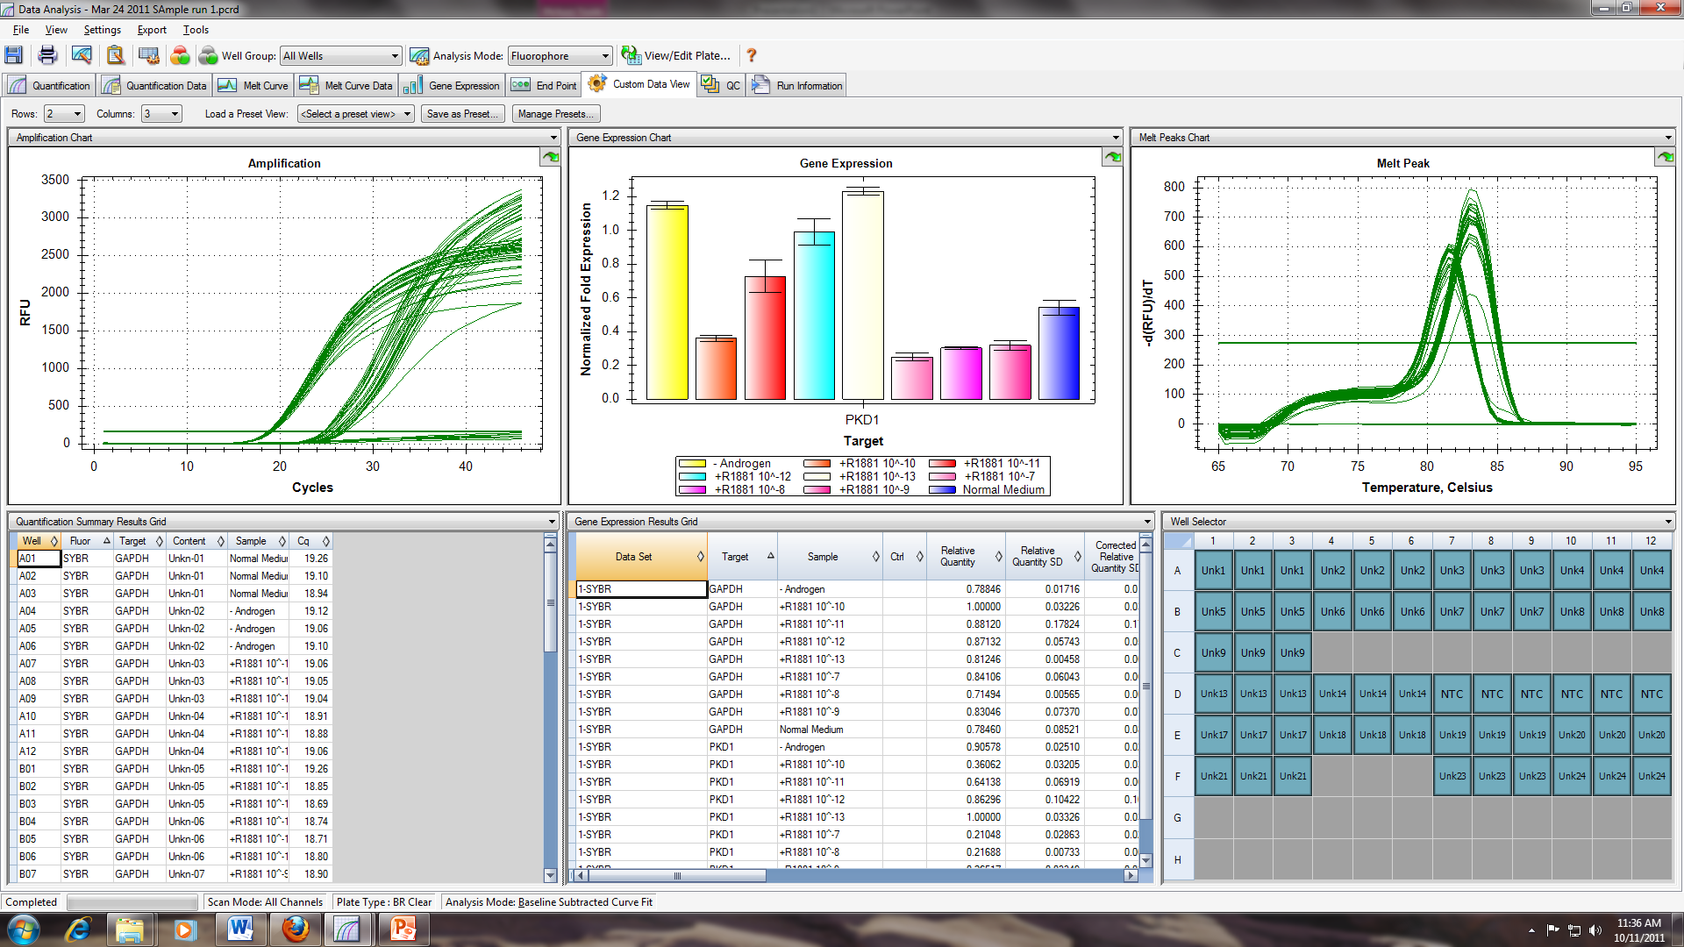

- Assay Validation and Optimization

  - Optimization of annealing temperature

The annealing temperature is the temperature at which the primers anneal to the target sequence so that extension can occur. This is probably the most important optimization step after correct primer design.

    - Inserting a temperature gradient and experimental design
- In order to determine the optimal annealing temperature for each primer set, reactions should be run on a temperature gradient. Setting up the temperature gradient is outlined in Section 3.2.3 above.
- The range of the gradient may vary according to the T_{m} of the primer set, but running a gradient from 55°C to 65°C should be sufficient for most well-designed primers.
- Even in optimization steps, samples should be run in triplicate.
- Be sure that your protocol includes a melt curve (Section 3.2.3), since this an important readout for optimization.

    - Analyzing the melt curve and C_{T} value, and determining optimal temperature

The optimal annealing temperature is determined based on 2 readouts: C_{T} value and melt curve analysis.

- The C_{T} value (threshold cycle, also called the Cq in the CFX Manager software) is the cycle at which enough amplified product has accumulated to yield a detectable fluorescent signal. This value is determined by the amount of starting template – the more template, the lower the C_{T}. After an assay run, the CFX Manager software will automatically calculate the C_{T} for each sample, and this will be displayed on the screen in the Quantification tab (amplification plot) and the Quantification Data tab.
- A melt curve is created by progressively increasing the temperature until the dsDNA products denature, resulting in a decrease in fluorescence. Ideally, each primer set will result in only one peak on the curve, the specific product peak. Non-specific products can be detected by melt curve analysis as well (including primer dimers, which will usually denature at around 75°C).

- The optimal temperature is determined by choosing the temperature that results in the lowest C_{T} with a single-peak melt curve.

  - Optimization of primer concentration

Primer concentration is important because it may affect the formation of primer dimers, which are detrimental to the success of the assay. Thus, primer concentration should be optimized along with annealing temperature. (Note: this step is not always necessary, and optimization of annealing temperature may be sufficient.)

    - Setup of primer concentration optimization assays
  - The recommended primer concentration for SYBR Green-based assays, using SsoFast EvaGreen Supermix, is between 300–500 nM. Therefore, it is recommended to test your primers at 300, 400, and 500 nM concentrations to determine the best conditions for your particular assay.
  - The samples should be run in triplicate.
  - Be sure that your protocol includes a melt curve.

    - Analyzing the melt curve and C_{T} value, and determining optimal concentration

As with the annealing temperature (Section 4.2), the optimal primer concentration is determined based on 2 readouts: C_{T} value and melt-curve analysis. (See section 4.1.2 for details)

- The optimal primer concentration is determined by choosing the concentration that results in the lowest C_{T} with a single-peak melt curve.

  - Standard curves: calculation of PCR efficiency to measure assay performance

The calculation of PCR efficiency by standard curve is necessary in order to determine whether the primers/reaction conditions previously optimized (Section 4.2) result in a similar amplification efficiency across a range of starting template quantities.

For each primer set, control cDNA should be used, and triplicates should be run at each of at least 5 serial dilutions of cDNA (while you can construct a standard curve line using only 3 or 4 points, 5 is considered much more optimal; example dilutions: 1) straight cDNA template, 2) 1:10 dilution cDNA, 3) 1:100 dilution cDNA, 4) 1:1000 dilution cDNA, and 5) 1:10,000 dilution cDNA).

The BioRad CFX Manager software will automatically calculate the PCR efficiency when the correct information is input into the program (i.e., indication of standards and dilutions used, etc).

Efficiencies in the range of 85–115% are considered usable, although 90–110% is more ideal.

During the actual experiment, after all optimization steps, the PCR efficiency for each primer set is used to assist with normalization of the assay results in the software.

  - Optimization of TaqMan probe reactions

For reactions using TaqMan probes, the primer sets should be optimized as above, separately from the probe, then the probe should be tested under the same conditions.

- Relative Quantification

In relative quantification, the “fold-difference” between samples is determined using a reference gene (such as Actin or GAPDH) to normalize the starting template amount. The ideal reference gene will not vary depending on cell type or treatment, and it is now common to use more than one reference gene to determine relative quantities.

The relative quantity is determined by analyzing the C_{T} for each gene and then determining the relative quantity based on the difference between C_{T} values for the target gene and reference gene.

The BioRad CFX Manager software will automatically calculate the relative quantity (ΔC_{T}) and normalized expression (ΔΔC_{T}) of your target gene if you have designated a reference gene on your plate. It also incorporates the calculated PCR efficiencies to make a more accurate quantification if you have run a standard curve or manually input the efficiency (in the Experiment Settings window).

For detailed discussion on the calculation of these values, see Section 4.2 of the Real-Time PCR Applications Guide provided by BioRad.

- Absolute Quantification

In absolute quantification, the actual quantity (number of copies or unit mass) is interpolated using a range of standards of known quantity.

For detailed discussion on the calculation of absolute quantities, see Section 4.1 of the Real-Time PCR Applications Guide provided by BioRad.

