Hitachi S-3400N VP-SEM Scanning Electron Microscope
User Guide
University of Puget Sound – Department of Biology
Original by: Jeff Tepper, Geology Department (3/2009)
Revised by: Courtney LaValle (8/2011)

Table of Contents

A. Scanning Electron Microscopy.............................................................................................................. 2 B. Safety Considerations............................................................................................................................ 2 C. Disclaimer!............................................................................................................................................... 2
D. Operation of the Microscope............................................................................................................... 2-8
- Sample preparation and before-you-begin hints............................................................................ 2
- Preparing and Loading Samples................................................................................................... 3-4
- Measuring the height and diameter of the sample mount............................................................... 3
- Inserting the mount and readying the chamber............................................................................... 3
- Inputting the specimen height and diameter................................................................................... 3
- Setting and adjusting the high voltage and probe current............................................................ 3-4
- Viewing in Secondary Electron Mode.............................................................................................. 4
- Automatic Brightness and Contrast Control and Automatic Focus................................................. 4
- Adjusting the Working Distance and Taking Images.................................................................. 4-6
- Raising and adjusting the stage...................................................................................................... 4
- Adjusting the scanning speed......................................................................................................... 5
- Taking and saving images........................................................................................................... 5-6
- Viewing in Backscatter Electron Mode (Z-Contrast Imaging)....................................................... 6
- Obtaining an Energy Dispersive X-ray Analysis (EDA)................................................................. 7
- Growing Ice Crystals in the SEM................................................................................................... 7-8
- The metal reservoir – location and placement................................................................................ 7
- Placement of the coldstage sample mount..................................................................................... 7
- Run settings.................................................................................................................................... 7
- Using the Peltier cooler................................................................................................................ 7-8
- Shut Down Procedures..................................................................................................................... 8

A. Scanning Electron Microscopy

The scanning electron microscope (SEM) is an instrument used for imaging in the biological, geological, and chemical sciences to visualize prepared samples and gain information on the surface topography, composition, structure, and other properties of the sample. Imaging with the SEM was first conducted by Manfred von Ardenne in 1939. Imaging with SEMs provides high resolution, greater depth of field, and very high magnification.

B. Safety Considerations

The primary risk of electron microscopy is radiation from the electron beam. However, since the unit is fully enclosed, there are generally no risks of radiation exposure as long as the unit remains in good condition. If you have any concerns about the condition of the instrument, please notify Amy right away (email: areplogle@pugetsound.edu; location: Room 127E, Harned Hall; phone: 253-879-2829).

C. Disclaimer!

Please note: this is an abbreviated guide. The actual manual for this microscope + software package is easily over 300 pages. While it is a good exercise for any student to read the user manual when beginning work on a new instrument, this User Guide can serve as a guide to general use of the instrument. However, in the event that you encounter trouble, need more information, or require assistance, contact Amy (email: areplogle@pugetsound.edu; location: Room 127E, Harned Hall; phone: 253-879-2829) or refer to the manual for the instrument or software.

D. Operation of the Microscope

Students should always have training on the microscope prior to use! To set up a training session on how to operate the microscope, or for assistance or troubleshooting, please see Amy in Harned Hall Room 127E (areplogle@pugetsound.edu or 253-879-2829).

- Sample preparation and before-you-begin hints

    - Before loading the sample, you may need to coat it with carbon or gold. We have both a carbon coater and a gold palladium coater in the SEM room.
    - If you will be saving images, you may wish to create a folder on the F: drive before starting the SEM operating software.
    - If necessary, click on the PC-SEM icon on the desktop to start the software. The username is PC-SEM; there is no password.
    - Under the “CONDITION” tab, choose either SEM (fixed pressure/high vacuum) or VP (variable pressure) mode.

- Preparing and Loading Samples

  - Avoid touching the surface of mounted samples (or wear gloves).
  - Measure the height and diameter of the sample mount using the white plastic guide. It is vital that the height be measured accurately; failure to do so could result in damage to the detectors.
  - Press the “AIR” button to allow air into the sample chamber. Alternately, click the “AIR” button located in the upper right section of the control panel.

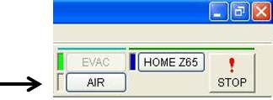

  - Once air has entered the chamber (approximately 1.5 min), open the chamber by pulling the specimen stage out.
  - Insert the mount, making certain that it is fully seated, then close the chamber and press the “EVAC” button. Alternatively, click the “EVAC” button located in the upper right section of the control panel. A message in the lower left corner of the monitor will indicate when the chamber has pumped down (approximately 2 min).
  - After the chamber is ready, a window will pop up. Input the sample diameter and height in the correct boxes. It is critical that the height be accurately measured and input, and the sample diameter is also important, particularly if you will be imaging with a very short working distance (distance from the specimen focusing point to the detector) and using the tilt feature.
- If you need to reset or change the sample size/height values, click on the “Set” button on the SPECIMEN block in the STAGE tab. This will open the Set Sample Size / Detector window. You can then input the height and diameter. Note that the “Set” button will be grayed out (unavailable) when the stage is raised up.

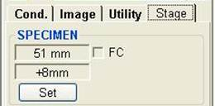

  - Click the “ON” button in the upper left to turn on the high voltage. We commonly run at 10–15 kV, but the choice of voltage will depend on the project. For example, when imaging with the VP system, voltages of 3–7 kV are more common.

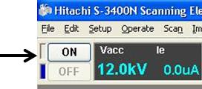

  - To adjust the voltage or current, change the values in the appropriate boxes under the Conditions tab, under the ELECTRON BEAM settings.

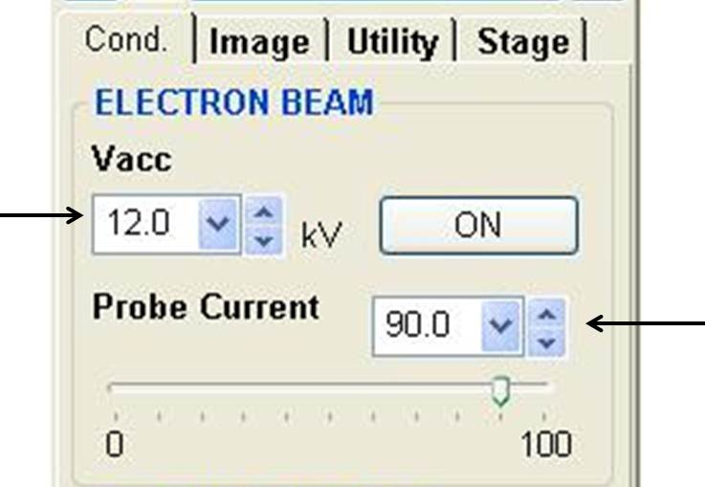

- Viewing in Secondary Electron Mode

- Under the “IMAGE” tab select “SE”. An image of the sample should now be visible. If not, check to see that the magnification is set to a low value. It may be helpful to click the “ABCC” button (Automatic Brightness and Contrast Control) and then the “AF” button (Automatic Focus). You can also focus manually using the controller knobs.

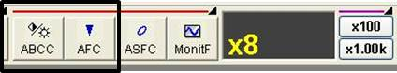

- Adjusting the Working Distance and Taking Images

  - At this point, you normally would raise the stage to the desired working distance. This distance will depend upon the project, but 10 mm is a good choice for routine imaging and EDS analysis. A shorter distance will improve image quality for high magnification work but will result in a shallower depth of field. For imaging with the VP system, it is essential to use a working distance of 10 mm or less. This is because with the VP system, air is introduced into the chamber; the farther away from the detector, the greater the interference of the air molecules with the electron beam. A distance of 5–8 mm is best for this purpose. Take great care to accurately measure your sample height.
  - You may wish to turn on the infrared chamber scope before raising the stage. This allows you to watch the stage move up and down inside the chamber. This camera is located to the left of the computer monitors on the desk. Push both the power on switch and button. Watch the camera to make sure it does not hit the backscatter detector (if the stage dimensions are correct, it should be fine). If it looks like it is getting too close, you can hit the STOP! Button on the top right of the window.

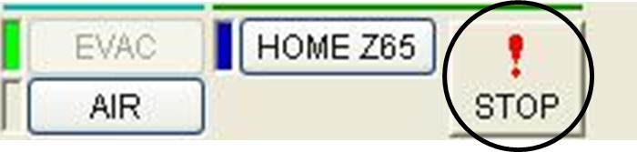

  - Controls for raising the stage are found under the “STAGE” tab. If you click on the “Focus Link” box, the image will continually refocus as the stage is moving. Input the working distance into the correct box (indicated by the top arrow in the image below) and then click the Go button.

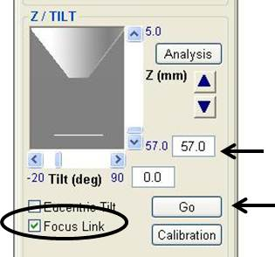

  - The scanning speed can be changed by clicking the appropriate box at the top of the window. Generally, for focusing and viewing, use a faster setting (such as Fast1), and use a slower setting (such as Slow3) for taking pictures to save.

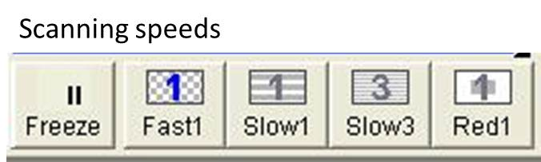

  - To take an image, switch to a slower scanning setting (above), then click on the 1280 button.

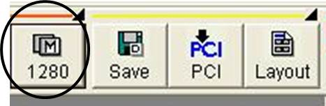

A window will pop up as the image is being captured. After the image has been successfully captured, another window will pop up at the bottom of the screen, the Captured Image window. Select your image in the window, and click the Save icon.

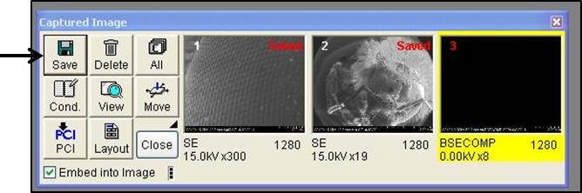

After you click on the Save icon, the Image Save window will pop up. Input the location, name, and type of the image file, and click Save.

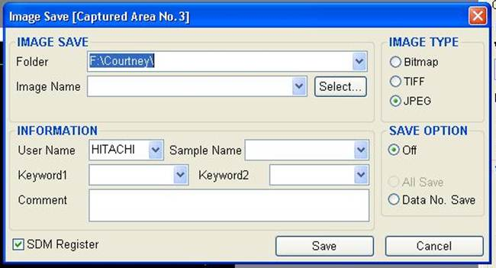

- Viewing in Backscatter Electron Mode (Z-Contrast Imaging)

  - Be sure the working distance is 10 mm or less and the chamber scope is turned off.
  - Under the “IMAGE” tab select the “BSE” detector. Set the gain as needed.
  - Focus as needed using the ABCC, AF, and manual focusing controls. It may be necessary to set the scan rate to SLOW 3 to get a usable image.

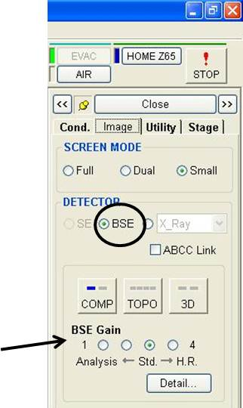

- Obtaining an Energy Dispersive X-ray Analysis (EDA)

  - Be sure the working distance is 10 mm or less and the chamber scope is turned off.
  - Be sure the accelerating voltage is at least 1.5 X energy of any element of interest.
  - Start the Noran System Seven software (NSS) from the start menu of the computer on the right.
  - You will be asked to create a project folder.
  - From the menu column on the left of the screen choose “SPECTRUM”.
  - Click the run button (the black arrowhead); a spectrum should appear.
  - To obtain a quantitative analysis of the spectrum, click on the quantify button.

- Growing Ice Crystals in the SEM (original version by Will Pfalzgraff in Nov 2009)

  - Air the chamber by pressing the AIR button in the software. It might ask you for the dimensions of your sample – put anything you want. When the software says “changing a sample is now possible,” slide the chamber open.
  - While the chamber is airing, record name, date, and time in the log book.
  - Fill the metal reservoir (found in the freezer in the main lab) with 3–4 mL DI water (not necessary if already filled and frozen) and place it on the shelf to the right on the inside of the chamber.
  - Make sure the backscatter detector is in position and the camera inside the instrument is on.
  - Wearing gloves, slide the normal sample mount off and place on the desk. (Gloves are not necessary, but be sure not to touch the top of the stub).
  - Pull the coldstage sample mount out of the bottom of the chamber and slide it onto the examination stage. Gently tighten the screw on top to hold it firm.
  - If required, change the stud using the Allen key labeled “cold stage” in the second drawer down underneath the sputterer.
  - Make sure the software is in VP mode with the desired total pressure. A good starting point is 50 Pa.
  - Slide the chamber door closed and press the EVAC button in the software. It will ask you for the dimensions of your sample. We use 51 mm width and +8 mm height for the copper stub. Enter these and hit ok to start pumping down the chamber. (This may take some time).
  - As the chamber is pumping down, go to the STAGE tab at the far right of the window. In the bottom right of the STAGE tab, enter the desired height for the stage. It should be set at the bottom, 57.0 mm. We want it as high as possible for best viewing, so enter “5.0” and hit Enter on the keyboard (or hit Go on the tab).
    - You can see the stage come up on the camera viewing screen. Watch to make sure it does not hit the backscatter detector (if the stage dimensions are correct, it should be fine). If it looks like it is getting too close, you can hit the STOP! Button on the top right of the window.
    - If you want to be careful, you can gradually move the stage up. First enter “20.0” into the box and hit Go. The stage will move up to 20 mm away from the detector. Then, enter “10.0” and hit Go. Finally, enter “5.0” and hit Go. The stage will then be in place.
    - After the stage is in place, turn off the viewing camera as this may interfere with the imaging process.
  - Sometime before it is done pumping down, it will say “HV Ready” on the screen. Press the ON button on the top right of the window to turn on the high voltage and begin viewing.
  - Under the Conditions tab, set the accelerating voltage and probe current. Good starting conditions are 12.0 kV for the voltage and 90-95 for the probe current.
  - Make sure you have a good view of the copper stub. Adjust the brightness, contrast, and focus manually using the knobs or automatically using the ABCC and AFC buttons in the software.
  - When the chamber is pumped down so that the total pressure is your desired pressure, flip the switch on the back of the Peltier cooler to turn it on. On the keypad on the desk, press the GOTO button, enter your desired temperature (usually -45°C), and hit ENTER.
  - Image the ice that grows. It is a good idea to use RED1 viewing mode for casual viewing because it refreshes quickly while staying nicely in focus (however, note that the field of view will be smaller). Take pictures in SLOW viewing mode by pressing the SAVE button and saving it to an appropriate folder on the F: drive. It is a good idea to number the pictures in the filenames. Once you have taken an image, press the RUN button in the software to unfreeze the screen and begin imaging again.
  - When you are finished imaging, press the AIR button. Enter anything for the dimensions of your sample. This will home the stage and open the chamber.
  - Set the Peltier cooler to about 20°C to melt the ice that is left on the coldstage. Once it is melted, gently wipe dry with a Kim Wipe. Press the OFF button on the keypad and hit ENTER, then flip the switch in the back to turn the cooler off.
  - If you are finished, remove the coldstage and place it in the bottom of the chamber. Replace the normal viewing stage. Remove the reservoir.
  - Follow the final procedures outlined in the Shut Down section (section 8).

- Shut Down Procedures
  - Turn off the voltage. Turn down the magnification.
  - Click on the Z65 button to return the stage to its loading / unloading position.

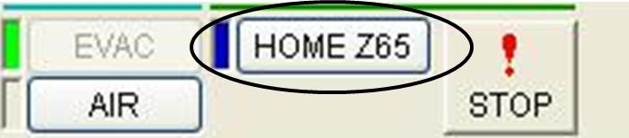

  - Turn off the infrared chamber scope if necessary.
  - Press the “AIR” button to allow air into the chamber.
  - Remove the sample mount.
  - Close the chamber and push the “EVAC” button.
  - Fill out the log book, put away your samples, and make sure the lab is neat before you leave!

