Mann

Economics 411: Economics of Nonprofit Organizations

A Bridge to Unite the Nonprofit Sector & the Federal Government: H.R. 5533

A Historic and Economic Critique

- Nina Felicia Genevieve Perl

Senior thesis submitted in partial fulfillment
of the requirements for a
Bachelor of Arts degree in Economics
at the University of Puget Sound
- Introduction

Throughout my thesis, I will describe how a new piece of legislation will affect the nonprofit sector. H.R. 5533, also known as the Nonprofit Sector and Community Solutions Act (NCSA), is in the process of being referred to the House Committee on Science and Technology. This legislation is an attempt to better unite the partnership between the federal government and the nonprofit sector. If this bill becomes law, it will have significant implications throughout the nonprofit sector. These implications can be viewed in both a positive and negative light. My study will provide examples showing how the NCSA could both benefit and hinder the nonprofit sector in the future. It is important to understand that my analysis of the bill will be limited to the influence of the government’s novel involvement with the nonprofit sector if NCSA is approved by Congress, signed by the president, and becomes law. It is not my intention to attempt to analyze whether this bill will be approved or rejected at any point during the legislative process. My focus simply will be to demonstrate the probable economic outcomes of the bill from the standpoint and assumption that H.R. 5533 will be enacted.
The NCSA was initially introduced to the House Committee on Science and Technology on June 15, 2010, by Rep. Betty McCollum (Minn.–D). This bill is the first to address the nonprofit sector in unison as a whole. It includes all legally recognized nonprofit organizations; regardless of their size, mission or earnings. Currently, the committee is deliberating the NCSA and the bill still has a long journey before becoming part of the U.S. legal system.
This study will provide a critical historical overview of the government’s past and current relationships with the nonprofit sector. I will analyze the weaknesses of these relationships, and how H.R. 5533 will attempt to remedy and overcome them. This paper is unique among thesis because, as of this writing, the bill has not been analyzed utilizing an economic model to demonstrate the economic effects it will have upon the nonprofit sector. This thesis proceeds as follows:
Initially, I will briefly outline the primary issues between the federal government and the nonprofit sector. My research will examine the current relationships between the U.S. government and nonprofit organizations and their shortcomings.
Additionally, Section two will analyze the consequences of inadequate information and how it can potentially affect the demand for nonprofit services and the ability of the nonprofit organizations to provide those services. Nonprofit organizations are created in response to both government and market failures. I will look at and examine the provisions of government and market theory. Media coverage is another relevant area of examination pertaining to this economic dynamic. Coverage of this bill throughout the life of the legislative process will inevitably impact and shape public opinion. With all these various elements shifting in response to the bill being exposed to the public, a shift in the labor market is worthy of examination. I will finish this section with a brief overview of past and current government and nonprofit relationships.
I will then present empirical data that demonstrates how important the nonprofit sector is relative to the United States economy and labor force. This will explain why the government will potentially benefit from the bill despite the expenditures incurred.
Section three reviews the structure and mechanics of the NCSA by explaining the four main components of the bill. I will thoroughly explain each segment and the government’s actions pending approval and proper execution of the legislation. The intent is to clarify the roles and interactions between the nonprofit sector and the government. The hope of government officials is to eliminate the lack of communication and information shared between themselves and nonprofits.
In Section four I will present my economic model, which will provide the main context of my thesis. Additionally, I will examine the legislation and its potential impact on the marketplace and demonstrate the demand and supply perspectives in regard to government-nonprofit relations. Throughout this segment I will argue what I think will occur as a result of the passage of this bill.
In Section five I will critique the results upon legalization of the NSCA. I will analyze both the positive and negative outcomes. This segment also will contain my data and results. I will provide suggestions for the improvement of this bill and other methods in which the nonprofit sector and the federal government can strengthen their relationship with each other.
Finally, I will conclude this paper with my thoughts about the limitations and difficulties of my study. This analysis will include my concerns and findings, and propose ideas for future studies and research in this area.

- Problem Statement

The federal government and nonprofit sector have a long history of a very imperfect and irregular relationship. Information regarding the nonprofit sector has been scarce and limited for some time. The public and federal government have been utilizing incomplete information in respect to the nonprofit sector. A lack of valid statistical information creates inefficiency problems regarding government regulation, legislation and policy-making decisions. William Thomson and Lord Kelvin, both build on this concept by stating:

When you measure what you are speaking about, and express
it in numbers, you know something about it; but when you cannot
measure it, when you cannot express it in numbers, your knowledge
is of meager and unsatisfactory kind: it may be in the beginning of
knowledge, but you have scarcely, in your thoughts, advanced to the
stage of science, whatever the matter may be.

Inconsistent data in regard to the nonprofit sector have increasingly become a considerable problem (Dale 1993). Statistical data in respect to the charitable sector have grown to be increasingly important for many reasons. Firstly, the data are necessary to inform and educate the nation about the span and diversity of the nonprofit sector. This would allow for us to increase both our appreciation of the charitable sector as well as improve our understanding of the nonprofit sector.
Secondly, if there were a more uniform and efficient gathering of data in relation to the nonprofit sector and its organizations, it would provide a more solid foundation for better legislation, regulation and bill formulation for the government.
And lastly, it would facilitate and focus the attention of our government to address the areas of study; research and inquiry would be insightful and helpful (Dale 1993).
My paper will analyze the government’s attempt to bridge this gap between itself and the nonprofit sector. I will demonstrate the impacts, both positive and negative, that H.R. 5533 will have on nonprofit organizations. Specifically, I will analyze their earnings and whether those earnings will increase, decrease, or remain constant with the implementation of the NCSA. Additionally, I will address the costs incurred by nonprofit organizations and whether these costs will remain constant, increase, or decrease. I also will analyze how this bill will affect the donors and employees of nonprofit organizations.

- Literature Review

The Literature Review is composed of three separate sections:(i) Theoretical approaches of dynamics of nonprofit organizations and government failures, (ii) empirical research of the nonprofit sector, (iii) and the history of current and past government-nonprofit relations.

- Theoretical Approaches

The government addresses the three sources of market failure, underprovision of collective goods, overexclusion from excludable public goods and contract failure, in unique ways.
Underprovision of collective goods is resolved in one of two ways: producing said goods or paying a private-sector business to produce them (often referred to as contracting out). An example of this would be correctional facilities or prisons. Some government entities operate departments of corrections, while others have chosen to hire private-sector contractors to provide the services - from building actual prisons to managing and overseeing incarceration facilities.
There are several ways that the government solves the problem of overexclusion from excludable public goods. If the government produces said goods, it is then in a position to dictate the terms of the exclusion. A government-owned and operated entity, such as a municipal golf course, can structure charges such as greens fees to reflect discounts for residents or any other select groups, thus favoring certain individuals and groups of individuals over others. Also, because governments are in a position to regulate private-sector businesses, they can mandate that everyone, even individuals who are not paying, have access to a particular services. An example of this would be 911 emergency telephone service, which telecommunications companies are required to make available free to all consumers. Finally, the government can inject cash into selected markets in the form of subsidies so all preferred businesses to compete for excludable public good. Two examples of this are housing subsidies and work programs for college students.
To remedy contract failure, the government also has a variety of options. It can facilitate enforcement, regulate representations and claims about products which businesses make and limit entry into markets through licensing and bonding.

Government failure

It is a relative truth that regardless of what government does, not everyone in the affected citizenry will be pleased with the levels of goods and services provided. The main reason is because the wants and needs of consumers vary greatly from person to person. Providing collective goods ensures that diversity will suffer because everyone receives the same things. This contrasts with private goods, which are consumed by different individuals in different amounts.
Lindahl pricing, which was developed and named after Erik Lindahl, seeks to solve the dilemma of collective goods by setting their prices based on individual consumer preference, i.e., someone who desires to purchase a larger amount will be charge a higher price than an individual who wishes to purchase a smaller amount. However, while fine in a theoretical sense, Lindahl pricing is rarely practical and rarely used in real-world situations.
When speaking of government failure related to the nonprofit sector, the failure is an inability to provide the level collective goods sought by "high demanders." As stated earlier, government cannot meet the expectations of all consumers, and thus only a few in the middle will be satisfied, while majorities on both sides will want either more or less. But it isn't only diversity of desire which contributes to failure. Diversity of opinions also plays a critical role. Governments attempt to remedy this through multi-level structuring and mitigation.
Collective goods, which are consumed by everyone, such a national defense, are further broken down into local collective goods, such as fire and police protection - which can and often do vary by local jurisdiction even in the same regional area. Consumers will most often choose to live in areas when the local collective goods most accurately match their wants and desires.
However, problems arise when consumers are allowed to take advantage of collective goods without paying for them. And when government attempts to remedy this with coercive payments (such as taxes) two types of failure ensue: individual payments are no longer voluntary and they are "not linked to either the amount of the collective good consumed or the individual consumer’s willingness to pay for that good." (Steinberg 2006).
Property taxes, which fund schools is a good example of this because everyone who owns property pays regardless of whether they have school-age children. Another problem falls along the lines of "see no evil." It is impossible for government to regulate or remedy abuses, which it cannot detect. This problem is seen most often in regulation of for-profit businesses and government contracts.
And finally, government often has its hands tied by the very document, which provides its legitimacy. Not only do constitutional restrictions limit the government from responding to the wants and needs of the majority, but they also can prohibit other industries from responding to consumer demands. Both Market System Failure and Government Failure are gaps within the consumer market, although they may not appeal to the majority demands.
The sole purpose of nonprofit organizations is to provide the public with services that both the government and market system neglect to fulfill. These inherent absences of goods and services demanded by the economy are recognized as both market failures and government failures. The government attempts to fulfill the needs of the majority, thus leaving selective gaps among consumers who are dissatisfied with the majority demands. Because the government will never appeal to anything other than the majority, the needs of those left in the minority are often met by the nonprofit sector (Weisbrod 1975). Typically, the goods and services not provided by the government are new and innovative. As a result, the government and majority of consumers are reluctant to support such activities.
Robert K. Goiedel and Ronald E. Langley’s 1995 economic study, Media Coverage of the Economy and Aggregate Economic Evaluations: Uncovering Evidence of Indirect Media Effects, is significant when analyzing the new bill that has repeatedly been publicized to the public. They examine the impact that economic media coverage has on the economy, and to what degree news coverage will affect economic conditions. They acknowledge the fact that society is more apt to follow the economy throughout a recession (Goidel, Langley 1995). This is relevant considering our nation is in a serious economic downturn. Their research concludes that news coverage of the economy and related events consequentially does have an impact on economic conditions. Although, the strongest effects were found to be when the media coverage was regarding negative economic reviews, there is still an influence. Goiedel and Langley conclude that the most significant effects on the economy occur when the media signals are mixed and open to a variety of understandings.
It is also important to understand how the media and information affect the labor market. An individual looking for employment will search for an optimal wage until it becomes too costly. When the marginal cost of the search becomes equal to the marginal return of the search the individual will stop looking.
This is the same for an employer in search of wage demands. When the expected marginal return of the search is equal to the marginal cost of the search the employer will no longer seek an employee. Therefore, the more costly any given search assumed by a worker or employer is, the less likely and/or shorter a search will be undertaken by a worker and/or employer. When an employer is hiring a worker, the total costs of search for employment is lower for the individual seeking employment. When a worker is seeking work, the main cost incurred is primarily the opportunity cost of time. Transportation costs and foregone earnings are also costs incurred by the worker (Stigler 1962).
There are numerous methods for a worker to acquire information regarding the labor market other than direct solicitation. A worker can use other forms of information such as newspapers, media outlets, employment agencies, advertisements and word of mouth. Information that a worker has in his possession regarding any labor market is capital. It was acquired through the costs of search and acquiring information. Yet, it is important to recognize that such information can often be imperfect and limited, and if the worker encounters these issues they will resort to direct solicitation. As the search is prolonged the marginal cost of the search will inevitably increase for both workers and employers (Stigler 1962). Workers are typically the party to pursue direct solicitation simply because it is less expensive for them to do so than for employers.
However, just as workers are in search of employment and incur costs, employers have a similar scenario with direct search costs as well. It is estimated that the search costs are in fact higher for a company versus an individual worker (Stigler 1962). There are several reasons for this. First, the employer typically takes on the majority of the search and identification costs. This is especially true when a company is searching for a worker with a specialized set of skills.
The costs of acquiring information will become relevant to the accessibility and availability of the information for the public to utilize. The more difficult it is for both the workers and employers to find and access relevant market information, the more costly the search for both parties. This effectively will increase wage rates demanded by the workers, and the employers will offer lower wage rates, due to increase costs of the search.

(ii) Empirical Research

Empirical and statistical research is extremely limited and patchy for the nonprofit sector (Salamon 1999). Due to this limitation most of the statistical data that can be found regarding the nonprofit sector is an estimate. There is no central systematic manner of data collection. Information can be found on the 990 tax forms that are submitted to the Internal Revenue Service. Additionally, The Census Bureau collects data on employment, private philanthropy funds, volunteer numbers finances and other relevant nonprofit data. However, none of this information is complied into a single report, or easily accessed by the public. Researchers and scholars investigate intently for segments of information on the nonprofit sector that may or may not be correct. A select few of the academics then compile their data and research findings into a volume that contains statistical and historical data of the nonprofit sector. Examples of these sources include the Nonprofit Almanac, the Internal Revenue Service and Bureau of Economic Analysis.
Although the nonprofit sector in comparison to for-profit businesses is not very large, it plays a significant role in the American economy and labor market. It is estimated that the nonprofit sector accounts for approximately 6 percent of all business organizations in the United States. The nonprofit sector includes an estimated 1.6 million (5.9 percent) individually diverse organizations. Together, these organizations had revenue of more than $670.3 million in 1996. This amounts to a total of 8.8 percent of the entire U.S. Gross Domestic Product. If we were to separately analyze the U.S. nonprofit sector and compare it to other nations, it would exceed the entire Gross Domestic Product of many countries, including Spain, Canada, India, Australia and the Netherlands (Salamon 1999).
Nonprofit organizations are also responsible for a significant amount of employment within the United States. Approximately 11.7 million individuals were employed by nonprofit organizations in 2001, amounting to 8.5 percent of civilian employment in the United States (Leete 2006).
Additionally, the nonprofit sector consists of volunteer labor. In 2000, it was estimated that 83.9 million people volunteered at nonprofit organizations, totaling 15.5 billion hours of service (Leete 2006). These statistics make it apparent that the nonprofit sector plays a significant role in the U.S. economy and is a vital element in the U.S. labor force. The nonprofit sector has and continues to flourish and grow steadily (Anheir 2006). In fact, the nonprofit sector is the fastest growing sector today, more so than the government sector and business sector (The Nonprofit Almanac 2008).
However, despite the nonprofit sector’s significant contributions to the U.S economy, empirical and statistical data regarding nonprofit organizations is limited and scarce (Anheir and Salamon 2006). Despite the nonprofit sector’s immense contribution to both society and the economy, the government does not allocate the resources needed for collection of data regarding nonprofits. However the government does grant this type of information compilation to other economic sectors. It has been recognized in works such as the Nonprofit Almanac that compiling data of the nonprofit sector is extremely challenging. The Nonprofit Almanac is a resource, published annually, that consists of data and statistical research on the nonprofit sector. Yet even the authors were confronted with the limitations of data available.
One of the many obstacles of acquiring information on the charitable sector is due to the power that states have and can exercise to control researchers’ access to information. A number of states will not even permit their data to be applied in any national estimates (Boris 2008). This can skew the numerical and demographic data of the nonprofit sector leaving unfilled voids and/or inaccurate factual information.
Another extreme hurdle that prevents the collection of data on the nonprofit sector is the North American Industry Classification System. This system was created to replace the Standard Industrial Classification System; however it doesn’t even have a specific section addressing nonprofit organizations. It is extremely inefficient and costly for researchers to find methods to overcome these obstacles. As a result many times scholars are forced to guess and/or estimate the number of nonprofit organizations in many cases (The Nonprofit Almanac 2008). The problematic process of obtaining information is not limited to the state governments. The federal government also has an acute problem with data collection. These voids of information are examples of the current challenges facing government-nonprofit relations.
It is important to understand how nonprofit organizations sustain themselves financially before analyzing how this piece of legislation will affect their revenues and expenditures. A nonprofit entity has three sources of income. The largest source of revenue (45%) is from charges and fees that they impose on their clients. For example, admission tickets to a museum or college tuition payments. The second income channel that nonprofit organizations rely on is from the government (30%). This is when the government, federal, state or local, award grant dollars to support their missions. Lastly, 25% of revenue is from donations and volunteer hours. Nonprofit organizations are unique in the sense that they receive donated labor. In 1996, $100 billion worth of volunteer time was donated to nonprofits (Salamon 1999). Private giving is generally cash or in-kind contributions other than labor. Any significant increase in costs or decrease in donated revenue can severely impact nonprofit operations and services.

- History of the Government Relations with Nonprofit Organizations

The federal government maintains two primary relationships encompassing the nonprofit sector today. The first and most key government-nonprofit relationship maintained by the government is the IRS (Internal Revenue Service). The secondary affiliation that the government maintains with the nonprofit sector is the Corporation for National Community Service. The IRS is to ensure tax compliance and regulation, whereas the CNCS is an agency the government has to support volunteer programs (Brothers 2010).
The federal government created the National Community Service in 1993. This was an act that would facilitate and promote American citizens to volunteer their time to the nonprofit sector. It is the government’s effort to help meet the volunteer needs of communities all over the country.
The government has been active in enforcing tax conformity among all nonprofit organizations. To ensure compliance they utilize the IRS Business Master File (BMF) system. This is a record of all existing active nonprofit organizations that currently file with the IRS, are registered and have obtained tax-exempt status. The information this file contains includes the name, address, exempt criteria, gross receipts and total assets of all nonprofit organizations. This list of information is the most inclusive and comprehensive available from the federal government. However, state attorney general offices compile similar records of all registered nonprofits within their jurisdictions (The Unified Registration Statement 2010). The majority of this information has been unchanged since the day the organization received their tax exemption. The data on the BMF list regarding a nonprofit entity can be inaccurate for years after they have closed their doors. Every few years, the list will be further updated when the IRS mails out postcards to all the listed nonprofit organizations to confirm their existence (Boris and Steuerle 1999).
Another portion of the IRS’s data collection includes the National Center for Charitable Statistics (NCCS) core files. This is where the IRS combines all information obtained from the BMF lists with all the information acquired using the Return Transaction Files (RTF). The RTF is a database created by the IRS consisting of the information on the 990 forms filed by the nonprofit organizations. The IRS combines the information from the BMF files and the RTF files to catch simple financial errors made by nonprofit organizations. Although the information provided by the IRS is potentially available to researchers and the general public, it is imperfect at best (Salamon 1999). An additional flaw of the IRS data collection system is that nonprofit entities, and religious groups, which have $5,000 or less in total annual earnings, are not required by law to register their information with the federal agency, although some still choose to do so. That creates a gap in the information collected by the IRS regarding nonprofit organizations because according to the NCCS, “The total number of these small organizations is unknown with scholars offering widely varying estimates.” (National Center for Charitable Statistics 2009). Therefore, a significant amount of small nonprofit organizations do not appear on the IRS registration records. So potentially, many active nonprofit organizations are continuously underrepresented, while other nonprofit organizations that have fallen inactive will continue to reside on the IRS information lists.
Other entities, such as the BEA (Bureau of Economic Analysis) try to accumulate research and data on the nonprofit sector that is available, and compose statistics. However, this system is utterly flawed with limitations and estimates. For example, the BEA divides the economy into four sectors: government, business, households and nonprofit institutions serving household (Nonprofit Almanac 2008). However, nonprofit organizations which serve businesses are reported under the business sector, not the nonprofit sector. As a result of these constraints, there is still no comprehensive gathering of information about the nonprofit sector. Although past accumulation of information was drastically worse, and has been improved over the years, the federal government is still confronted with an extremely flawed collection of data on the nonprofit sector.

III. The Proposed Legislative Solution

As a result of these past and current relationships between the nonprofit sector and the government, a bill was drafted with the intention of allowing the government to cultivate a more productive partnership with the nonprofit sector. This bill, H.R. 5533 (NCSA), will allow for better communication, coordination and understanding between the U.S. government and all nonprofit organizations. In addition, one of the key provisions of this act will be a government-designed enhanced data collection plan. In order to fulfill these objectives, NCSA includes four specific mandates.
The first requirement specified within the bill is the creation of a 16-member council that will be called the United States Council on Nonprofit Organizations and Community Solutions. Each member of the council will be appointed by a federal leader. The selection will be as follows:

I) The president will appoint a total of five members of the council.
II) The majority leader of the House of Representatives will appoint three members.
III) The minority leader of the House of Representatives will appoint two members.
IV) The majority leader of the Senate will appoint three members.
V) The minority leader of the Senate will appoint two members.
VI) There also will be a non-voting member on the council. This will be the chair of the Interagency Working Group on Nonprofit Organizations and the Federal Government. (This will be instituted under section 201 of the bill).

It is important to note that the members who are selected to serve on the council must meet certain prerequisites. To be eligible to participate on the council, prospective members must have widespread expertise and experience in respect to the nonprofit sector (H.R. 5533, Section 3. Purposes.). Some of these areas of expertise include the function, management, support, or operation of a nonprofit organization. If a potential member doesn’t meet any of those qualifications, he or she must have a history of social entrepreneurship and/or innovation. Prospective appointees also may qualify for inclusion on the council if they have extensive qualitative and quantitative research experience, or a history of business management of any philanthropic or nonprofit organization. All members of the council are required to be appointed no later than 60 days after the bill goes into effect.
This council will have several responsibilities. It will study the relationship between the federal government and nonprofit organizations nationwide. In doing so, the council will determine ways in which the government can work more effectively and efficiently alongside the nonprofit sector to achieve improved outcomes for addressing the national and community hardships. The council also will study the nonprofit sector's role within the U.S. economy and how effectively nonprofit organizations tackle extensive challenges of national interest and empower their communities.
The second area of interest for the council will be the interaction between the federal government and nonprofit organizations. Specifically, members will study how the federal government interacts with nonprofit organizations in affiliation with state and local governments, other industries and philanthropic organizations to address national and community challenges (H.R. 5533, Section 1 U.S. Council on Nonprofit organizations and Community Solutions.). In doing so the federal government can then recognize, address and correct the current inefficiencies of this correspondence.
Another responsibility of the council will be to determine how the federal government can assist nonprofit organizations in implementing programs that have been successful at addressing national and community failures. These programs will be federally funded.
One of the duties of the council will be to determine simpler methods of obtaining federal grants by eliminating the inconsistent, difficult and contradictory requirements inherent in the current system, thus enhancing accountability for nonprofit organizations.
Additionally the council will determine new processes in which the federal government can contract with nonprofit organizations. This will allow for an expansion of eligibility for smaller nonprofit entities, thus eliminating unfairness and wasteful oversight. The council will focus on eliminating the barriers that deter small nonprofit organizations from participating in federal programs.
The council also will examine the possibility of creating an online database that will be utilized by nonprofit organizations and the federal government to promote and facilitate communication among nonprofit organizations and help them share best practices.
Members of the council will continuously analyze how they can improve the quality and quantity of the data collected about nonprofit organizations. This data will consist of information about nonprofit organizations as employers and the economic impact nonprofit organizations have on the economy. The council will find ways to eliminate the current gaps in the data and to make this information easily accessible to the general public. The council will be intent on dismantling these barriers that deter small nonprofit organizations from participating in federal programs.
The council will advise the president and Congress about improving the existing grant programs offered to nonprofit organizations, as well as present new grant program ideas. These new grant programs will help nonprofit organizations fulfill national and community challenges, and promote social innovation.
The second section of this bill will consist of the president establishing the Interagency Working Group. The membership of this group will be as follows:

I) The presidents assistant for Domestic Policy.
II) The executive director of the NSCA.
III) The leader of Faith-Based and Neighborhood Partnerships.
IV) The head of the Office of Social Innovation and Civic Participation.
V) The CEO of the Corporation for National Community Service.
VI) The director of the Office of Management and Budget.
VII) The commissioner of the Internal Revenue Service.
VIII) The director of the Census.
IX) The chair of the National Endowment for the Humanities.
X) The chair of the National Endowment for the Arts.
XI) The president's assistant for Domestic Policy will serve as chair of the group.

The Interagency Working Group which is made of government officials, unlike the United States Council on Nonprofit Organizations and Community Solutions whose membership is comprised of individuals from the private sector also has specific duties that it must fulfill. The group will specifically consult, expand and implement the policies and recommendations of the USCNOCS. Additionally, it will award and create new grants and contracts to nonprofit organizations, and identify new techniques for better managing the federal government's relationship with nonprofit organizations. The Interagency Working Group will work in close unison with the USCNOCS regularly. These departments will coordinate projects, and assist with ensuring the implementation of the proposed reforms by the USCNOCS.
The third vital element of H.R. 5533 is the collection of data. It will be the duty of the secretary of the Department of Commerce to accumulate and assemble all data that the department has in regard to nonprofit organizations. This data will become publicly available no later than one year after this bill becomes law. Additionally the secretary will create an economic report that will include statistics describing the economic impact that American nonprofit organizations have on the U.S. economy.
Additionally, this bill will compel the director of the Office Management and Budget to write a report regarding all direct and indirect funding that is provided to nonprofit organizations by the federal government via contract and grants.
Employment data will be collected by the secretary of the Department of Labor and the department will be required to ensure that all employment data is given to the Bureau of Labor Statistics. The Bureau of Labor Statistics will be required by law to include nonprofit organizations as a category in its employer reports.
Census data will be collected on an annual basis as well. The director of Census will be required to collect all information regarding the nonprofit sector and create a comprehensive report. This report will include all sub-categories of nonprofit organizations, regardless of annual revenue. When the director of Census has completed the report, it will be submitted to the president and Congress.
Finally, this section of the bill will obligate the Interagency Group and the U.S. Council on Nonprofit organizations to create a document recording the following:

1) Nonprofit organizations' clientele. This will be a collection of the clientele's ethnicity, gender, income level, geographic location, and age.
2) The nonprofit organizations' financial standing and health.
3) The fiscal amount of charitable donations made by corporations, individual donors, and foundations.
4) The amount of volunteer hours that were donated to nonprofit organizations by individuals.

The fourth mandate that this bill includes is the creation of a Nonprofit Research Fund. This will be a grant fund of $5,000,000 for fiscal year 2011. This money is earmarked solely for research and training. Specifically, money will be provided for the training of how to properly study and analyze nonprofit organizations and their activities. The fund will also subsidize the research of nonprofit organizations, their importance and their impact on their communities.

IV. Economic Model and Analysis of NCSA upon implementation?

Government failures are typically reassured by nonprofit organizations and the services they provide. However, inevitably the nonprofit sector cannot fill all the governments voids throughout society, and unavoidably suffer from them as well. The problem of inadequate information in the nonprofit sector is inevitably interconnected throughout the entire system and has detrimental effects on charitable organizations today. For example, the lack of information causes an uneven and inaccurate distribution of information regarding NPOs (NPO Sector Assessment 2008). Consequentially, this market distortion on the nonprofit sector is ripe for political inaccuracies. The current political voice and influence that the nonprofit sector contains is limited and almost non-existent. The bill would eliminate these barriers and promote awareness of the nonprofit in the federal government by granting the organizations a seat at the government table. Furthermore, rational ignorance would no longer be an option for lawmakers to avoid acknowledging the needs of the nonprofit sector. (CITE). The NCSA is obligated to remove all information barriers.

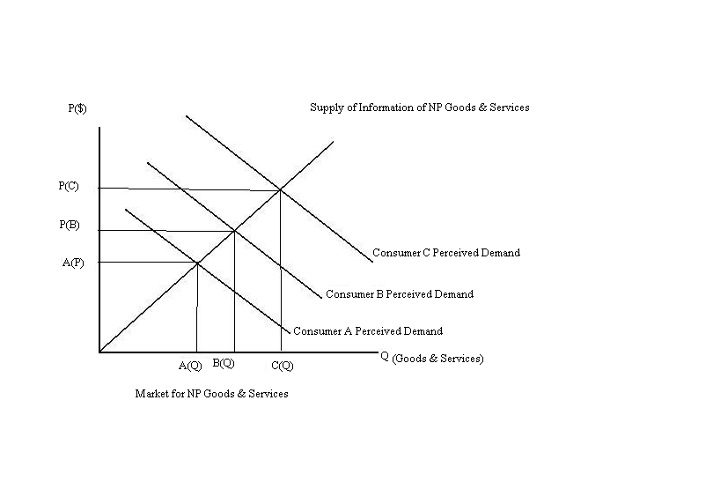
Figure 1.
Consumers purchasing goods and services from the nonprofit sector currently view and value these expenditures differently based on their utility received from their donated time and/or money. Due to the lack of information available from the federal government, it is impossible to determine what the demand of a nonprofit consumer is because of the lack of comprehensive data available for them. Above in Figure 1, the demand curves demonstrate the different magnitudes of the consumer’s perceived value of consuming nonprofit goods. This graph demonstrates how buyers perceive the value goods of nonprofit services differently. Additionally, the demand curve represents how the quality of information that is available is not comprehensive. It has been addressed in The Economist that it is necessary for a market to have access to accurate information or else it will cause the market to inevitably overvalue the goods in the marketplace (The Economist 2008). This essentially will lead consumers and markets to miscalculate the worth of the goods and services that the nonprofit sector provides, leaving the purchaser with an unrealistic value of the product.

Just as inadequate information has the power to cause consumers to overvalue their perceived views on nonprofit goods, a comprehensive report created upon the approval of H.R. 5533, will have the influence to properly inform consumers. This will permit buyers to properly access their perceived consumer demand of nonprofit goods and services. The bill will eliminate all barriers of information of the nonprofit sector and create an accurate and healthy equilibrium between the consumer demand and supply of nonprofit organizations.

Media and Coverage

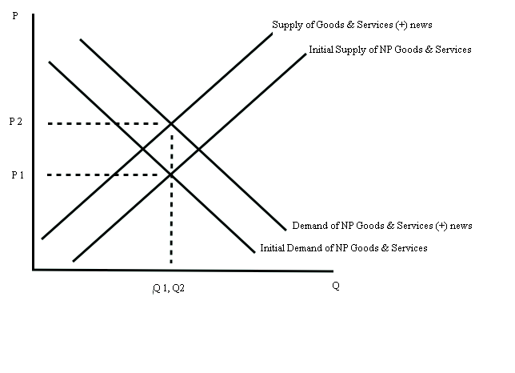
Figure 2.

As a result of limited information, consumers often evaluate the events presented in the media as a basis to interpret their decision making process in the nonprofit sector. Inevitably they allow these media outlets to impact the decisions, basing the information presented to the public as a source of information (Goidel, Langley 1995). If the media presents a negative outlook regarding the nonprofit sector, society effectively will mold economic evaluations accordingly (Mutz 1992). The formation of this bias in society will inevitably distort consumer behavior and the economic outcome will be shaped according to the media’s attitude. Figure 2 demonstrates a positive media outlet about the nonprofit sector, which is followed by an outward shift in demand of nonprofit goods and services. Consequentially, the new demand curve forces the prices to increase and a new equilibrium point is met. The supply curve shifts to reflect the change in prices, causing consumer perception of goods to be greater than before. Due to the increase in perceived consumer value, goods and services become less available to demanding consumers, and a buyer can only purchase them at a higher price due to the increase in the demand.
Effectively, if the NCSA bill came into effect the news media would envelope the nonprofit sector creating an instant increase in media coverage. This ultimately would filter numerous new sources of information to the public on nonprofit organizations, subject to interpretation by consumers. Having analyzed the bill, the position the media would present to the public would be a positive presentation. This would give consumers an instant source of information prior to the government compiling a comprehensive source of data of the nonprofit sector as the NCSA proposes to create. The above evaluation shifts in the demand and supply curves will then be subject to authenticate themselves in the economy today, creating a sharp increase for nonprofit goods and services. This essentially would procreate a positive product for nonprofit organizations nationwide, due to the positive media coverage.

Labor Market for Workers & Employers

In respect of the ongoing government failure to provide both workers and employers with information on the nonprofit sector, the costs of searching for employment and employees remains higher than necessary. This is detrimental to consumers actively pursuing employment as well as employers seeking employees because the high costs will discourage both parties. Workers seeking employment will soon discontinue their search when the information costs for a job will exceed the cost of their potential wage rate. Similarly, the when the costs of obtaining information for new employees becomes costly, it effectively pushes the wage rate of the new employee who is hired.

Upon legalization of the NCSA, both employers and laborers seeking employment will face lower costs of obtaining information. This will facilitate employment among the nonprofit sector, for both the companies and wageworkers. This will facilitate and provide many more accessible avenues for laborers to use when seeking employment. These compilations of information, and media coverage will similarly lower the costs of search for the employer.

Private Giving

Susan Rose-Ackerman states in Ideals versus Dollars, Charity Managers, and Government Grants that as private giving awards increase to a nonprofit organization, their private donations decrease. She explains that when a nonprofit organization receives a grant, they solicit fewer donors because of the fall in demand needed by the entity. It is costly to fundraise and solicit donors, so as a result if the organization does not need to, the manger lowers these costs. Yet, if government grants fall the manager will in turn react and increase their fundraising expenses and solicit donors once again to meet this overhead (Rose-Akerman 1987).

Figure 3.

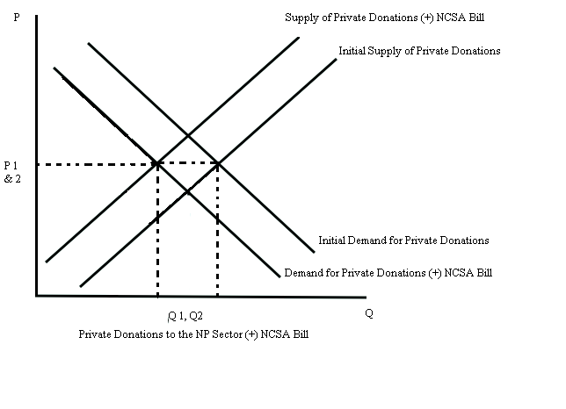
Above in figure three you can see where the initial market equilibrium is, Q1. This is before the implementation of the NCSA act. If the bill goes into effect, it will coordinate communication between the government and nonprofit sector, essentially improving the coordination and organization. In Section 4, Research of the NSCA drafted bill, it states that this act will study methods in which it can facilitate, make faster and more efficient ways of grating grants and subsidies to nonprofit organizations. As you can see this will cause a private donations to decrease. Ultimately, this gives the United States more power, influence and control of nonproft entities. If the government continuously grants money to thousands of nonprofit organizations across the nation the government will have more control over the nonprofit sector than that already do.

Volunteer Hours

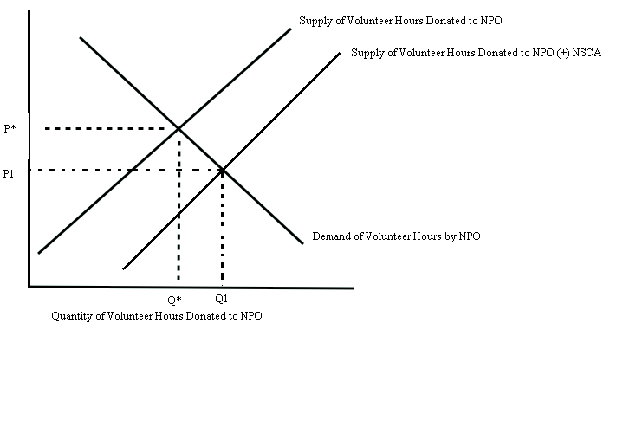
Figure 4.

With an increase in government involvement alongside the nonprofit sector after the successful implementation of the NCSA, we would witness a drastic increase in volunteer hours. Salamon states that as the government increases its involvement with nonprofit organizations we will witness the government, especially during natural disasters, essentially create public arousal in the volunteer market for nonprofits (Salamon 1987). In figure 4, the supply of volunteer hours shifts out, but the demand for volunteer hours remains constant. This is because if the bill passes, the nonprofit sector will not instantly have a demand for more volunteers.

Costs incurred by NPOs as a Result of NCSA

This is a serious issue that all nonprofit organizations need to consider when voting and analyzing this bill. It is important to recognize that this bill will ultimately impose many costs on the nonprofit sector as a whole. As you can see below, I have graphed the effects of Section 4 in the bill. It will impose higher average variable costs, which in turn increases the total costs incurred by all nonprofit organizations nationwide. The bill states that nonprofit organizations will be obligated to collect detailed accounts of their clients including clientele's ethnicity, gender, income level, geographic location, and age - as well as provide the government with their organizations' financial standing and health, the fiscal amount of charitable donations made by corporations, individual donors, and foundations, and the amount of volunteer hours that were donated to nonprofit organizations by individuals. This will impose a great burden on almost all nonprofit organizations, especially the smaller ones across the nation. I forecast that as a result, we will see many smaller nonprofit organizations disappear under this government demand.

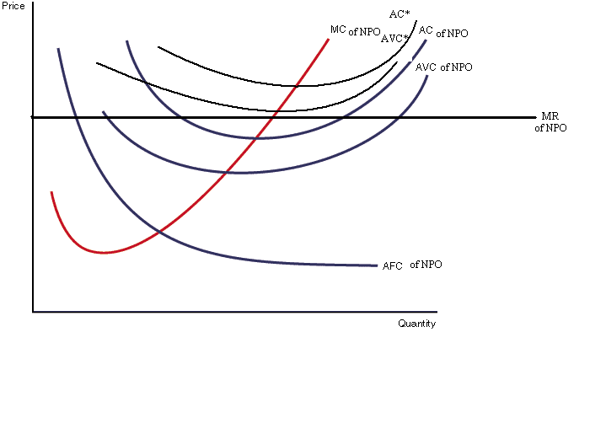
Figure 5.

Conclusion
Although there is a significant lack of information regarding the nonprofit sector, I do not find the benefits the bill to outweigh the costs of the bill. On the contrary, I see the increase in overhead to the nonprofit sector to significantly outweigh all the benefits of the media coverage and information compilations. There are other avenues of information reportedly annually on the nonprofit sector, even if there are difficult to access. Additionally, the political influence and standing that the government would acquire over the sector is concerning and could hinder nonprofits by indirectly regulating their operations and finances.

Works Cited
- Anheir , Helmut K, and Lester M. Salamon. "The Nonprofit Sector in Comparative Perspective ." Nonprofit Sector - A Research Handbook. 2. (2006): 89-114. Print.
- Blackwood, Amy, Wing Kennard T., and Thomas H. Pollak. Nonprofit Almanac 2008. 7th. Washington DC: Urban Institute Press, 2008. Print.
- Boris, Elizabeth T., and Eugene C. Steuerle, eds. 1999. Nonprofits & Government: Collaboration & Conflict. Washington DC: Urban Institute Press.
- Brothers, John. "H.R. 5533: How the Nonprofit Sector Can Rally for a Seat and a Table." Stanford Social Innovation Review 25 Aug. 2010: Web. 10 Dec 2010.
- Dale, Harvey P. "On estimating the size of the nonprofit sector in the US economy." International of Vouluntary and Nonprofit Organizations. 4.2 (1993): 183-189. Print.
- Goidel, Robert K, and Ronald E. Langley. “Media Coverage of the Economy and Aggregate Economic Evaluations: Uncovering Evidence of Indirect Media Effects” Political Research Quarterly. Vol. 48 No.2(1995): 313-328. Print.
- Laura, Leete. “Work in the Nonprofit Sector”, in Richard Steinberg and Walter Powell, editors, The Nonprofit Sector Research Handbook, 2nd edition, Chapter 7, pp. 159-179, Yale University Press, 2006.
- McCollum, Betty. United States. Landmark Legislation Gives Nonprofit Sector Official Voice in Government. Washington DC:, 2010 . Web. 16 Feb 2011. <www.mccollum.house.gov>.
- "NCCS." National Center for Charitable Statistics. Urban Institute,
2009. Web. 16 Feb 2011. < http://nccs.urban.org/resources/faq.cfm >.
- Richard A., Posner , and Landes William M. "The Influence of Economics on Law: A Quantitative Study ." Journal of Law and Economics. 36.1 (1993): 385-424. Print.
- Salamon, Lester M. 1999. America’s Nonprofit Sector: A Primer. 2nd ed. New York: Foundation Center.
- Stigler, George J. “Information on the Labor Market.” The Journal of Political Economy. Vol. 70, No. 5, Part 2: Investment in Human Beings (October 1962), pp. 94-105
- "The Unified Registration Statement." The Unified Registration
Statement- The Multi-State Filer Project . National Association of
Attorneys General , 2010. Web. 16 Feb 2011. <www.multifiling.org>.
- United States House of Representatives H.R. 5533, Nonprofit Sector and Community Solutions Act
- Weisbrod, Burton A. 1975. “Toward a Theory of the Voluntary Nonprofit Sector in a Three-Sector Economy.” Altruism, Morality, and Economic Theory. 171-195. Print.
- NPO Sector Assessment, Philippine Report. 2008
- The Great Untangling. (2008, November 6). The Economist

This would be the first time that the government would initiate a sustained and coordinated involvement regarding the nonprofit sector as a whole (McCollum 2011).
In the past, federal government bills dealt piecemeal with nonprofit issues; however NCSA would apply to the nonprofit sector as a whole. This projected law will not exclude any legally recognized nonprofit organization for any reason (McCollum 2011).
Richard A., Posner , and Landes William M. "The Influence of Economics on Law: A Quantitative Study ." Journal of Law and Economics . 36.1 (1993): 385-424. Print.

